Alabama Mushroom Society Newsletter
October 2023
Greetings everyone!
The summer is zooming by and I hope you are getting a chance to get
out into the woods!
The season for fungi faires is upon us. We had a magnificant time at
the 2023 Annual NAMA foray in Hendersonville, NC. We will be sharing a
recap by AMS Scholarship winner Bucky Reader in next months newsletter
about his first NAMA experience.
The Georgia Mushroom Festival is coming up at the end of this month.
Stop by and say hi to us at our booth over in the Vender Villiage. Poisons FB Group
AMS Board

President
Alisha Millican
Vice President
Jil Sea
Treasurer
Spencer Lowry
Secretary
Becca Mahoney
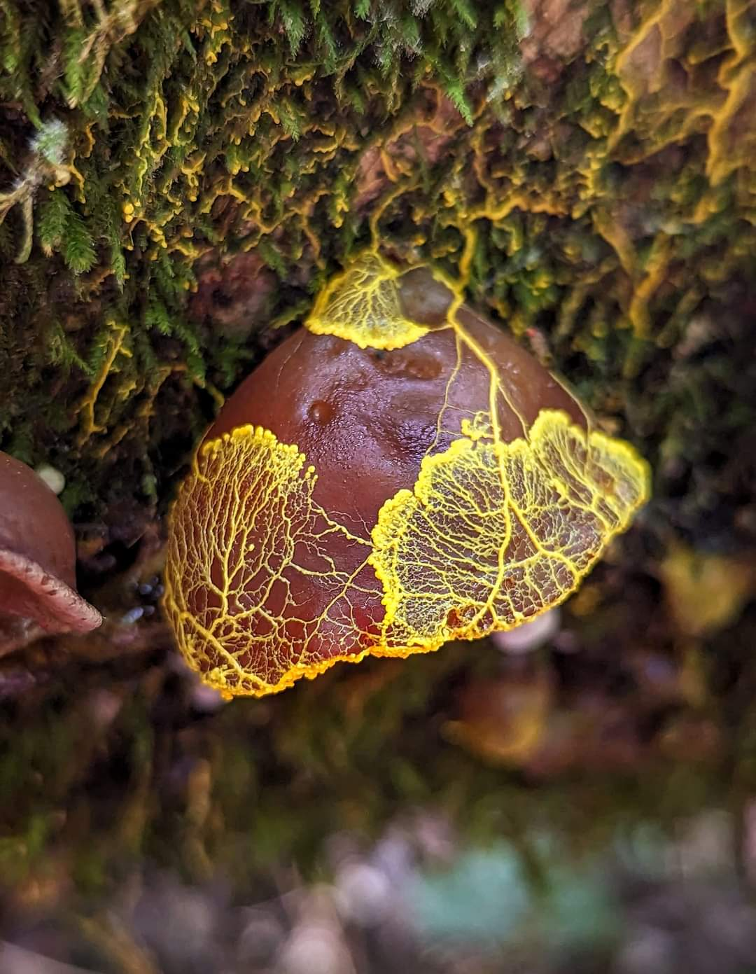
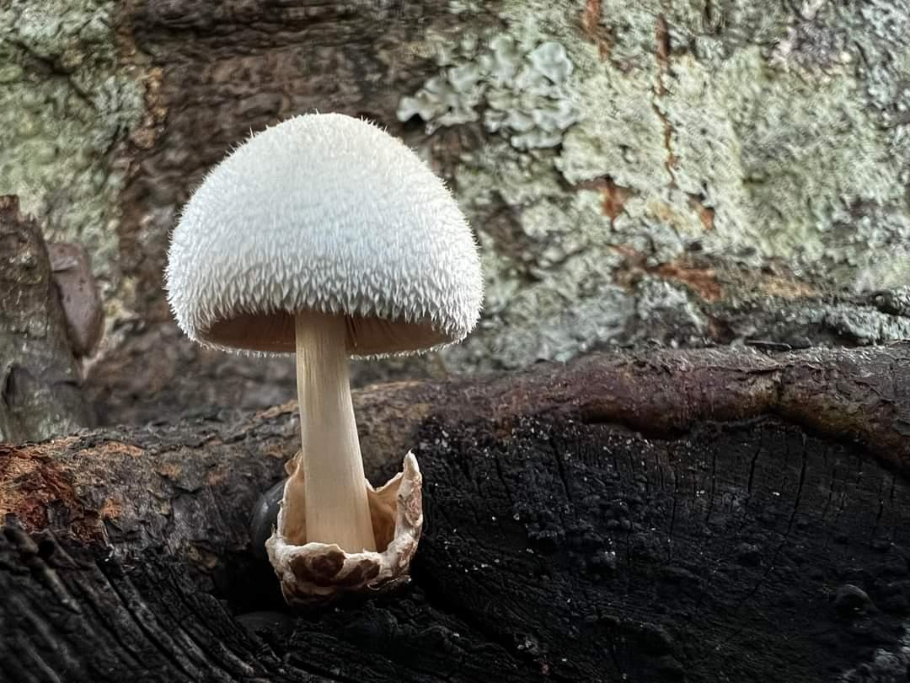
Our very own second annual Alabama Mushroom Faire is coming up
quick! October 7-8 in Battleground, Alabama, just outside Cullman. Tickets are
on sale now and if you would like to submit an application to be a
vendor, we are still taking them as well. Our schedule of events is finalized and
we have a SUPER exciting line up of presentations and demos by some of the top
mycologists and experts in the US! There will be activities for all ages and interest
levels! We are expecting an excellent turn out. If you haven’t got your
tickets yet, go get them HERE. Read about everything we have lined up on the
AMF page HERE.
Get out there, and I'll see you in the woods!
-Alisha Millican
AMS President

Volvariella bombycina by Jonathon Cendi Stevens
Auricularia with slimemold by Kristi Zoebelein
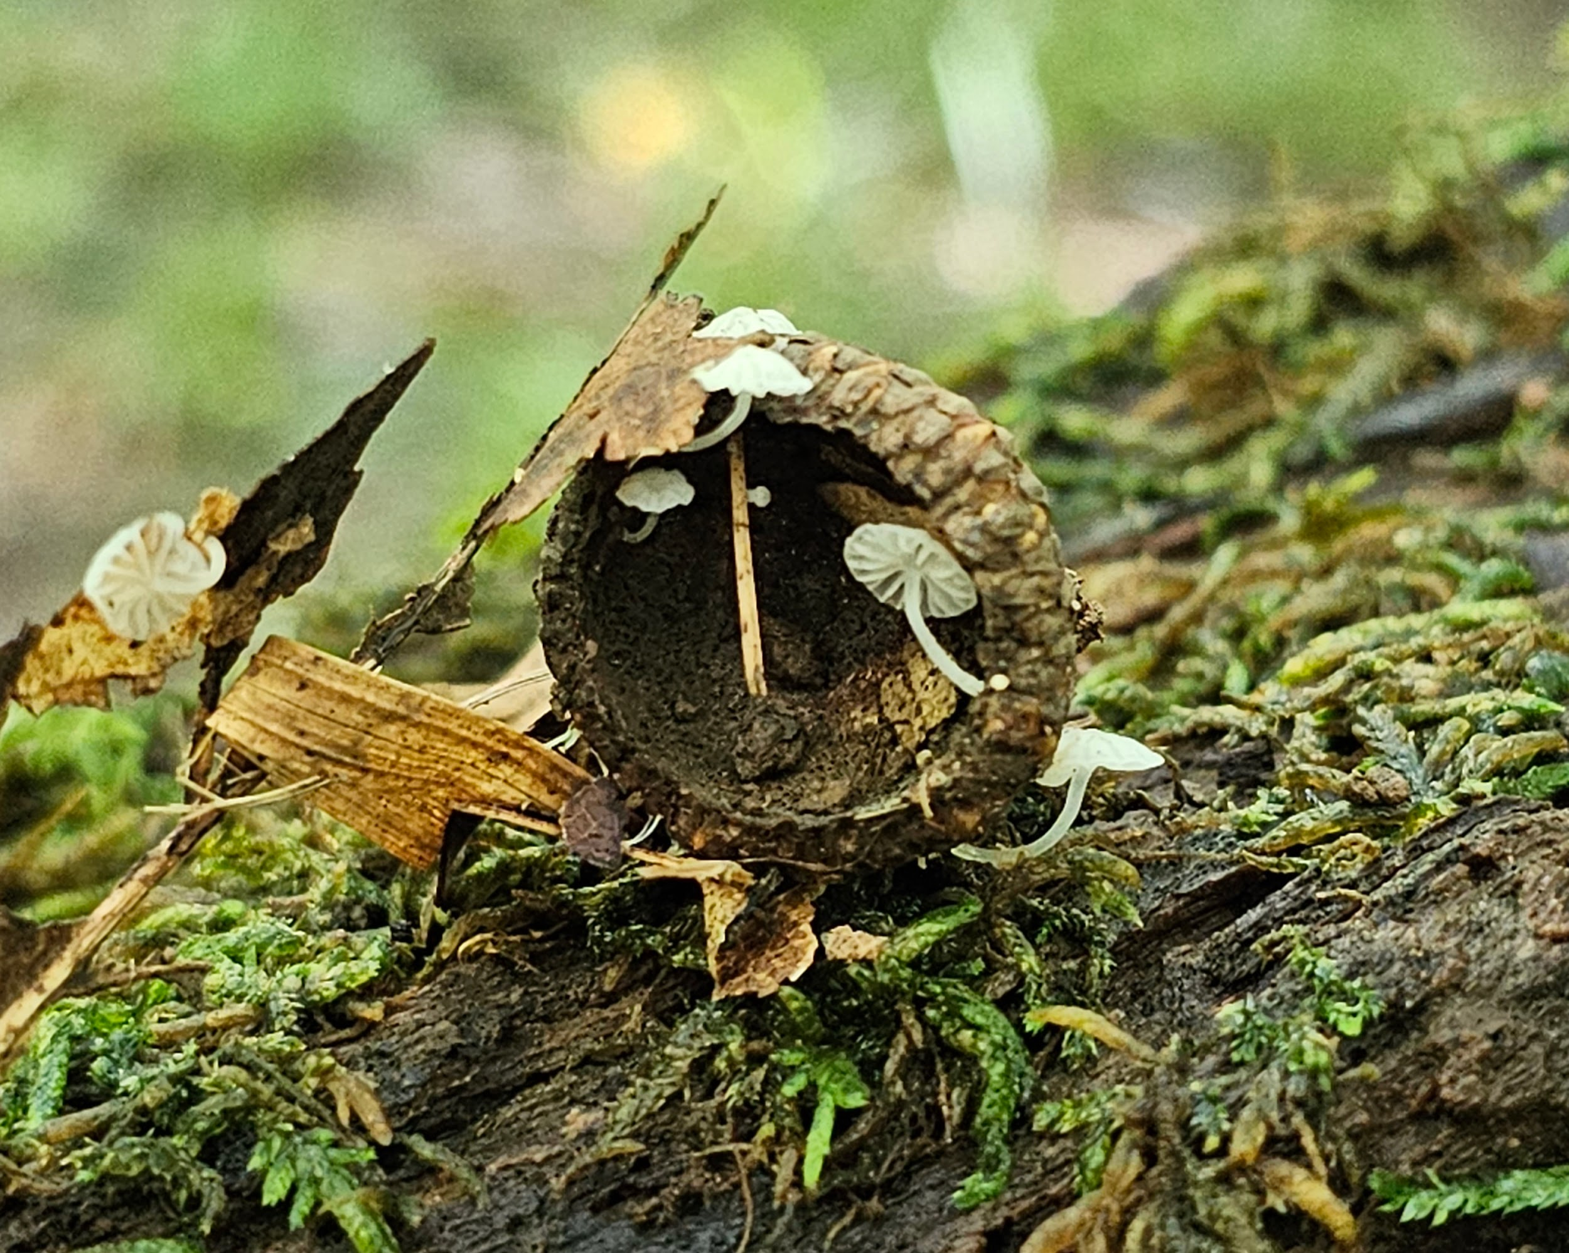
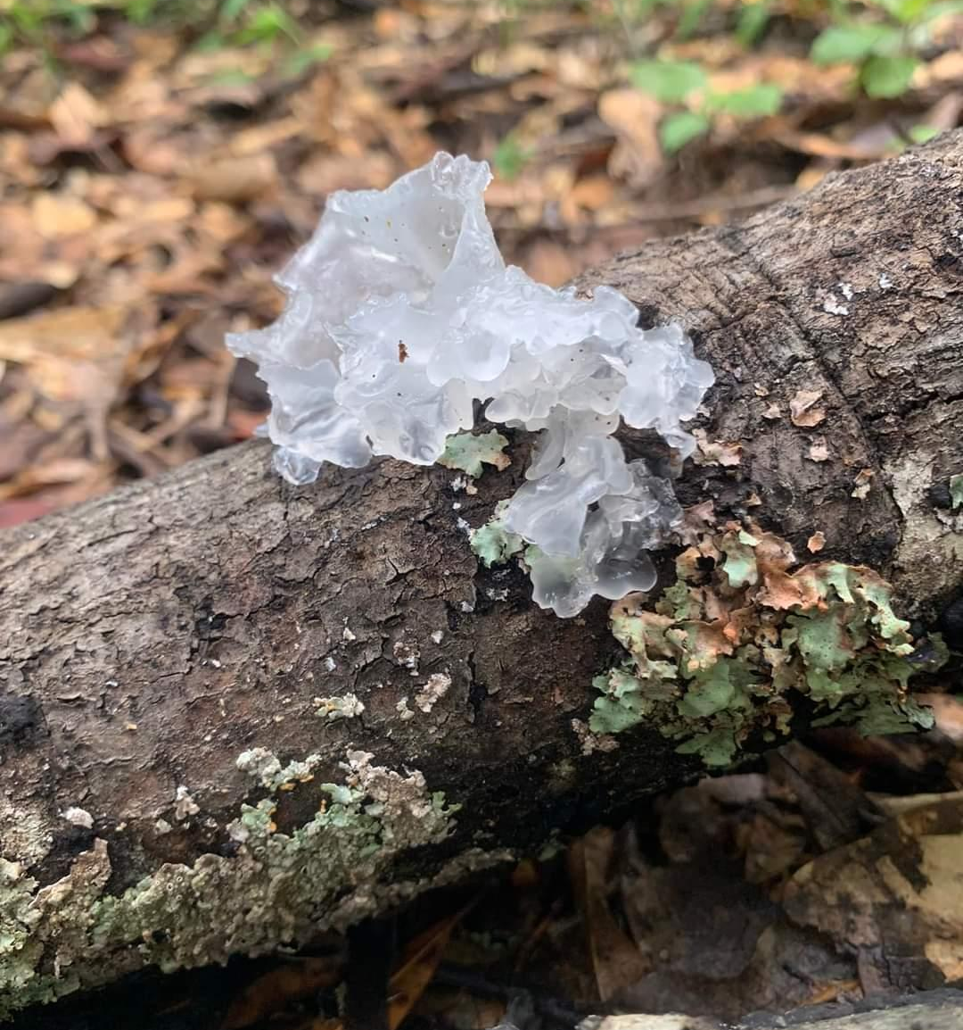

Tremella fuciformis by Joshua D Sorrow
Delicatula integrella by Leigh Maness

Upcoming Events
Click →HERE← for more info or to register for an event!
Oct 7-8th --------------------------------------------------------------Alabama Mushroom Faire
Sept 9th --------------------------------------------------------------- Jefferson County Monthly Foray
Sept 9th --------------------------------------------------------------- Cullman County Monthly Foray
Sept 9th --------------------------------------------------------------- Baldwin County Monthly Foray
Sept 16th --------------------------------------------------------------Elmore County Monthly Foray
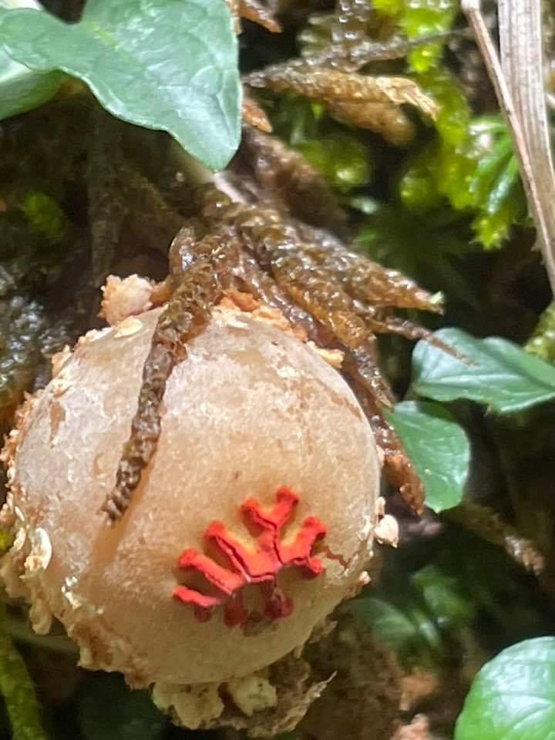
Sept 17th --------------------------------------------------------------Madison County Monthly Foray
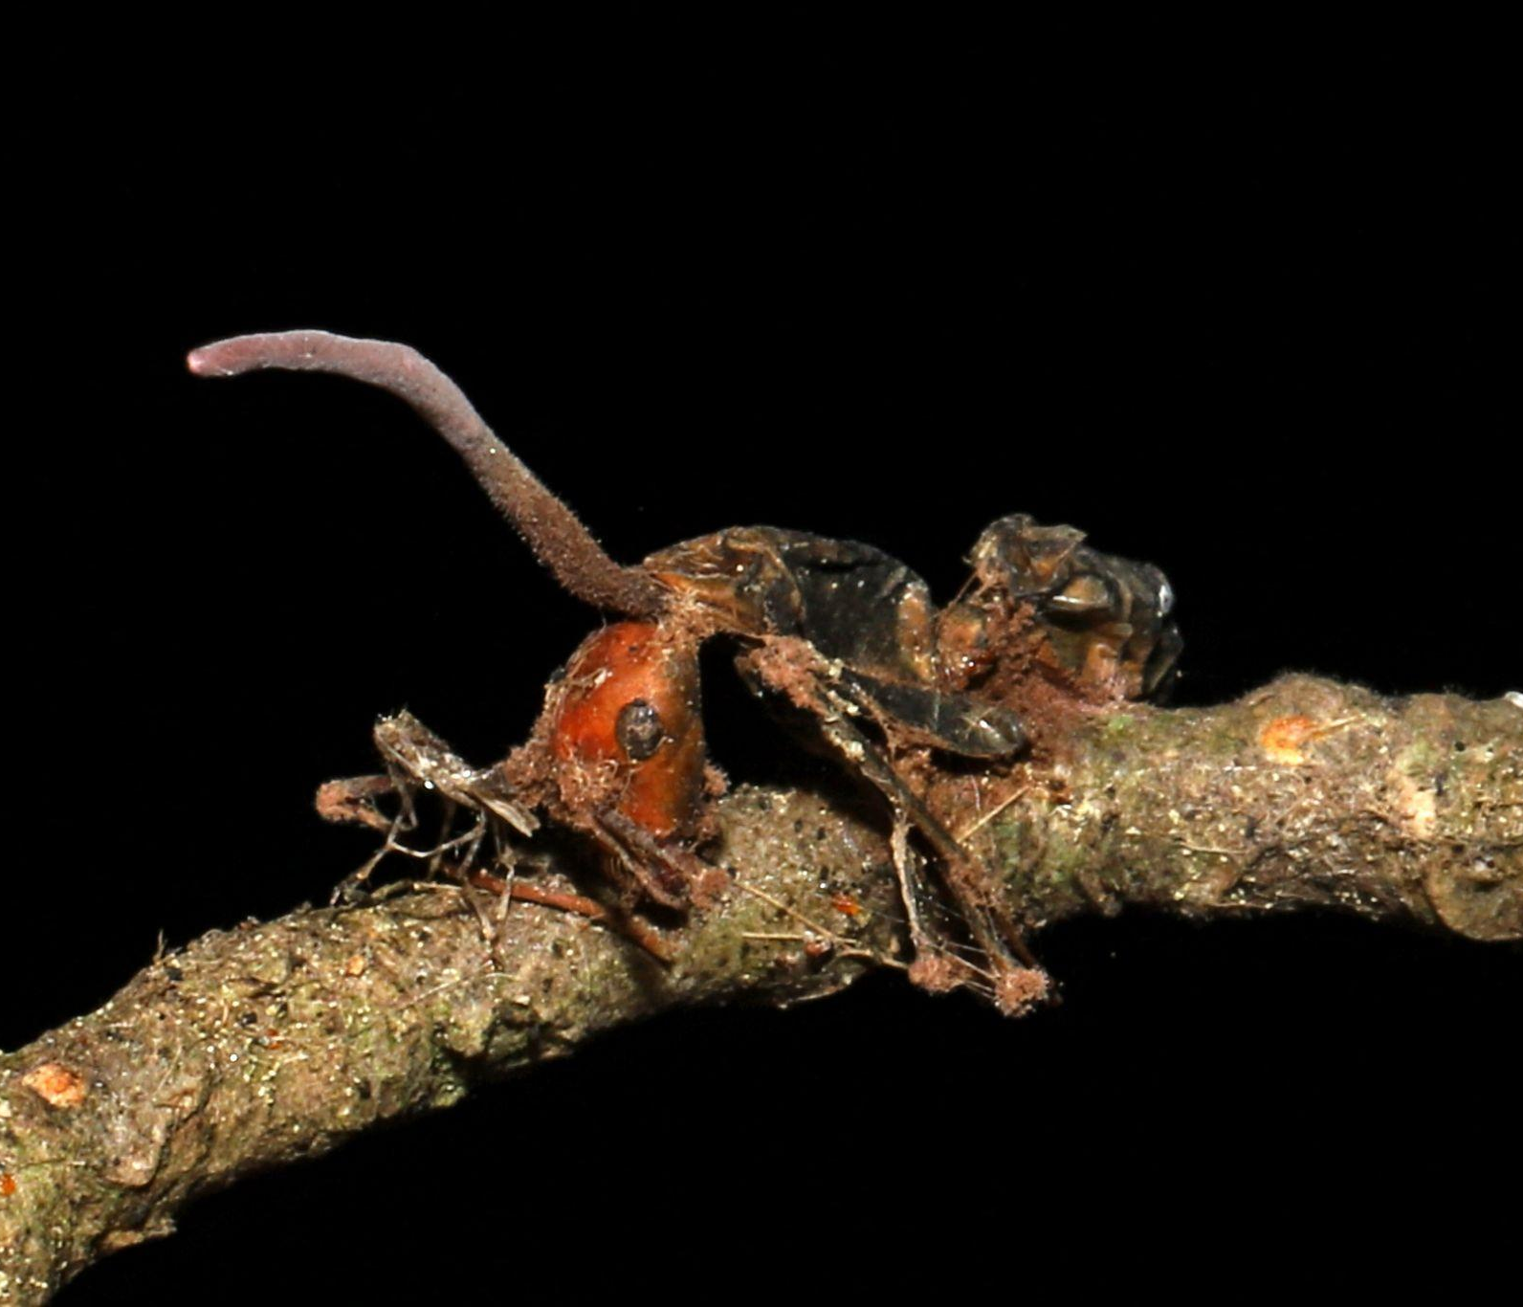

Ophiocordeceps kimflemingiae by Flown Kimmerling
Calostoma by Brent Holman
Mushroom of The Month
Tremella fusciformis
By Kit King
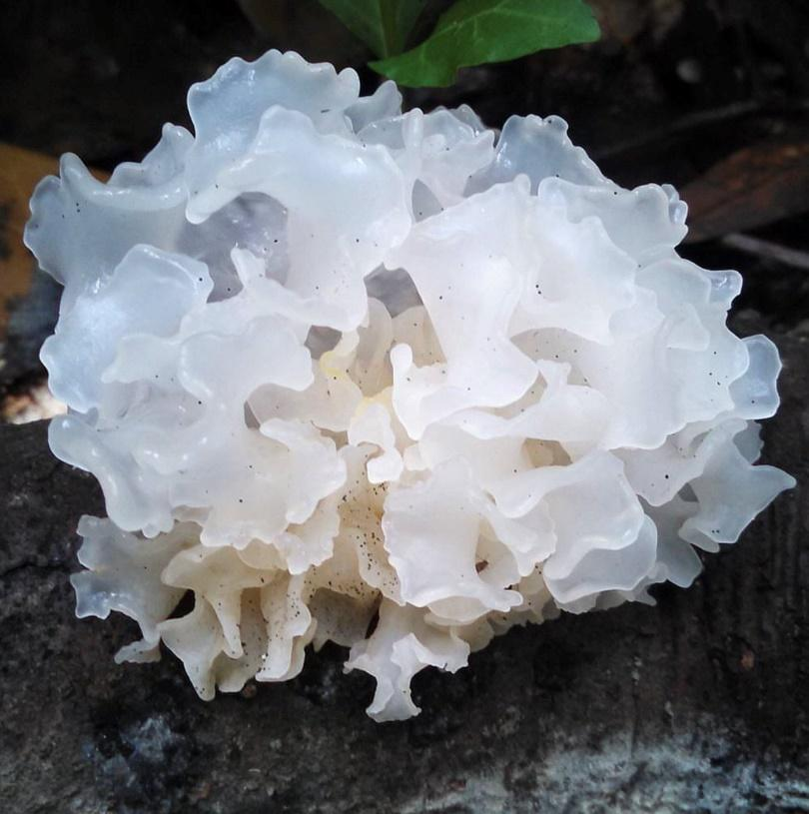
All photos credited to the author
A luminous jewel of a mushroom, Tremella fuciformis occurs on dead hardwood branches in the damp, dark woods of our southern forests and throughout the tropics. Emerging after heavy rains in summer and fall, the fungus is easily identified by its translucent white fronds and firmly gelatinous texture. The foliose structure of its fruiting body is reminiscent of seaweed. It can be quite large when fresh, nearly fist sized, and is easily spotted at this stage due to its size and milky white glow. It’s not hard to understand how this mushroom got its common name: the Snow Fungus.
During dry weather, the Snow Fungus takes on a tea-colored hue and begins to shrivel. The lovely, plump fronds become thin and brittle as the fruiting body desiccates. When the next soaking rain comes, the mushroom will rehydrate but it will never fully recover the splendor of its original state.
A freshly picked Snow Fungus does not have a distinguishing taste or smell. Its watery texture is slippery with a light and pleasant crunch. It has been a popular edible mushroom in numerous Asian countries for centuries, where it is commonly eaten as a desert. In one version of this dish, fresh or rehydrated Snow fungus is submerged in a lightly sweetened syrup and is served as a cold and refreshing soup.
Tremella fuciformis is a complex organism. A dimorphic fungus, it can transition between two phases, existing either as a single celled yeast or as a multicellular fungus, complete with hyphae. The transition between these two phases is influenced by its parasitic relationship with fungi in the genus Annulohypoxylon. These hard, dry fungi commonly appear as black balls or bumpy crusts on decaying hardwood.
T. fuciformis begins its lifecycle as a parasitic yeast, manifesting as a thin, nondescript slime. It continues in this phase until it comes in contact with its host. In association with certain species of Annulohypoxylon, T. fuciformis can access the nutrients it needs to transition into its multicellular phase. This transition is characterized by rapid mycelial growth that ultimately leads to the formation of the glistening white fruiting body we are familiar with.
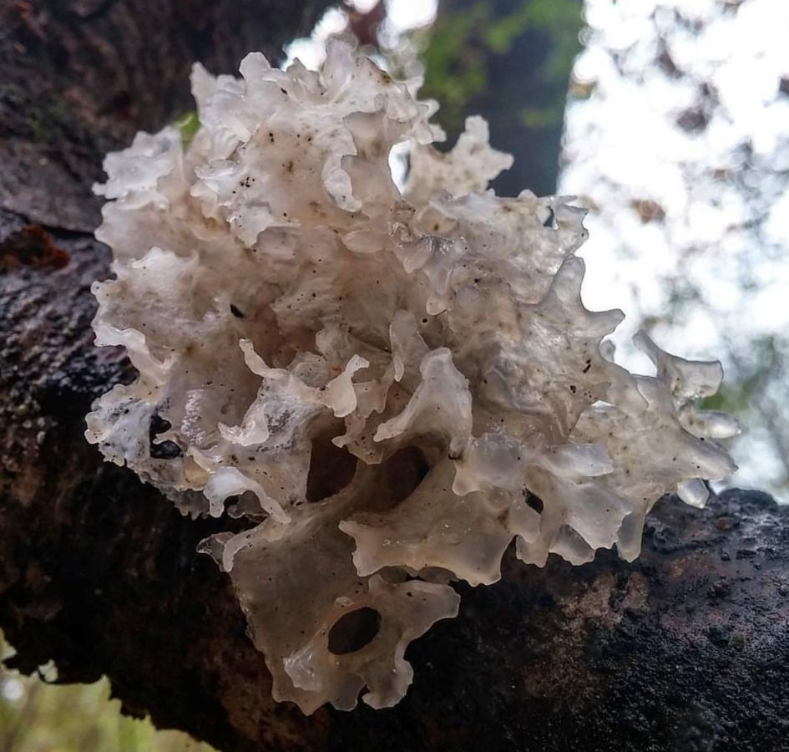
Like all species of Tremella, T. fuciformis is a mycoparasite. However, its relationship with its host is not entirely understood. Annulohypoxylon fungi are saprobes, releasing enzymes which digest the dead wood on which they grow. Perhaps T. fuciformis simply scavenges for nutrients while its host does the work of producing enzymes. Or maybe T. fuciformis directly parasitizes the mycelium of its host. It is also possible that the relationship is communalistic rather than traditionally parasitic. More research is needed to fully understand the interactions between these companion fungi.

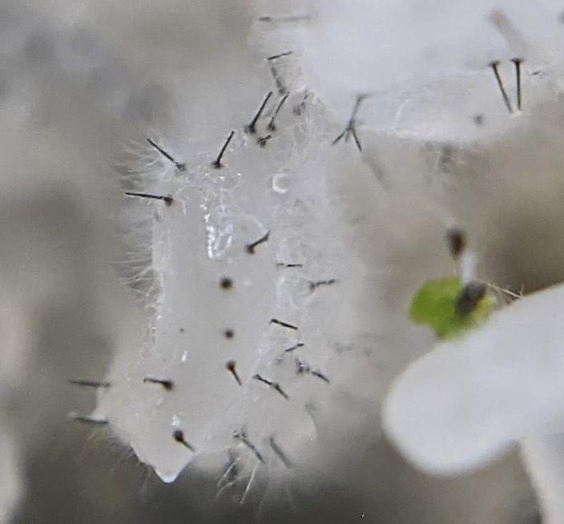
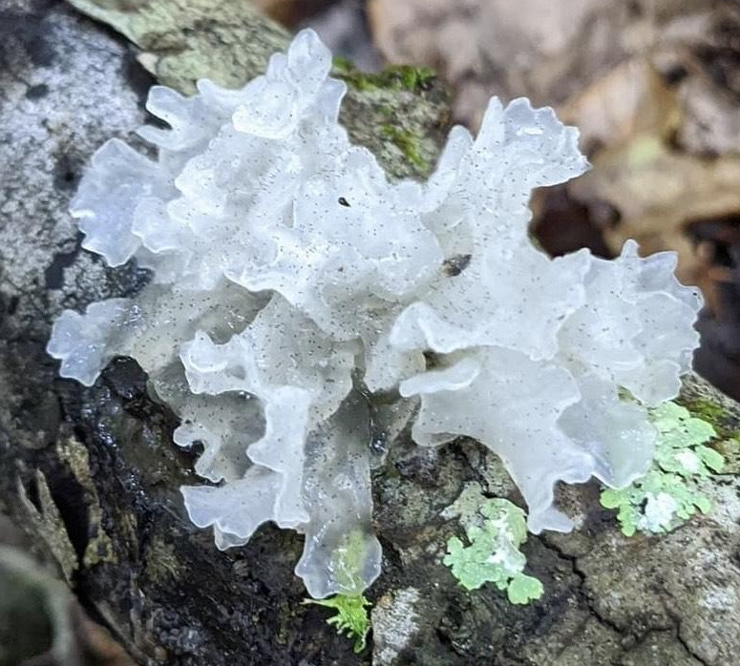
The complexity of this mushroom and its relationship with other fungi is further complicated by the fact that Tremella fuciformis, a mycoparasite itself, actually has a parasite of its own! Next time you find a fresh snow fungus, take a closer look and you may see the tiny, black, pin shaped fruiting bodies of Sporothrix epligloea. Like T. fuciformis, Sporothrix epigloea is also dimorphic and can transition between a single celled, yeast like fungus and a multicellular fungus with a mycelial network. The polysaccharide rich basidiocarp of T. fuciformis provides S. epigloea with the nutrients it needs to complete its transition from a soil dwelling yeast to a multicellular fungus capable of developing a fruiting body.

The complicated relationship between Tremella fuciformis and its fungal companions is a delightful reminder that we have only scratched the surface of our understanding of the mushroom realm. The intricate microbial interactions that take place all around us drive the cycles of decay and renewal required to sustain life on our planet. While we may never fully comprehend the complexities of these relationships, each new discovery offers us more insight into the interconnectedness of all living things.
Fungi Foragecast
By Anthoni Goodman
As always, rains continue to determine our mushroom hunting success. A good rain map will be your key for determining the best locations for a good forage. This map is my go-to.
October brings lower temperatures and (hopefully!) scattered rainfall for most of Alabama, this will dramatically shift our fungal finds. These changes will be most obvious following cool rains and sudden temperature shifts ushering in our cool-weather fungi while warm-weather fungi will 'migrate' South (and I don't mean a literal migration!).
Cool weather will see polypores popping from added growth rings ofFomes or similar hard/woody and long-lasting fruitbodies to the lovely lavender of Trichaptum sp. For the best polypore finds, wait 3-8 days following several intermittent rains or a big rainfall. Seems like a perfect time to pick up the latest Bessette book on Polypores (Polypores and Similar Fungi of Eastern and Central North America).
Cool-weather polypores will include tremendous flushes of Trametes such as
T.'s betulina, versicolor, lactinea, aesculi, and hirsuta. Look for them on almost any dead wood, especially somewhere near a source of water (creek beds are especially popular hangouts for betulina). Trichaptums and Stereums will also see massive growth adorning the deadwood with violets, whites, orange, and vermilion - perfect for autumnal photography.
This is also the beginning of the "big-birds of the wood's" growth season in the South. This means Laetiporus (already being somewhat frequently encountered in September) species (the Chicken of the woods [C.O.W.]) will become more and more commonplace (you're looking for L.'s cincinnatus on the ground, sulfureus and gilbertsonii on deadwood). Meripilus sumstinei, the black-staining polypore and jokingly called 'Rooster of the Woods' by Michael Kuo, will also make a more pronounced appearance alongside some Bondezarwia berkelyi (Berkeley's polypore). Last but certainly not least of the 'Big Birds' is Grifola frondosa - the Hen of the woods (also maitake, sheep's/rams' head, etc.) which will start showing up in greater numbers as autumn swings into full gear. Look for these at the foot of oak trees.

As for the Agaricales (those gilled toadstools) - expect another dramatic shift which will follow the cool temperatures from north to south and promote absolutely humongous honeys (genus Armillaria and ringless pseudo-genus Desarmillaria), lots of Laccaria (especially in sandy-piney areas), ramped-up Russula production (expect lots of the red and purple-capped varieties), and plenty of Pluteus & Pleurotus (with less and less bugs as temperatures drop, also more Pleurotus dryinus/levis). Lactarius species will shift from the heat loving varieties to the hyper-colorful Lactarius deliciosus groups (section Deliciosi) which include L.'s indigo, subpurpureus, paradoxus, chelidonium var. chelidonioides, and other green-staining Lactarius. Other Lactarious include: salmoneus, atroviridis, croceus, hepaticus, and so many others (for more information on this group see Kuo's page here). If you're far enough South, you might also find some of the late Craterellus flushes.
Wax-caps (family Hygrophoraceae) and Tricholomas are also going to start showing up. From the extra-viscid Gliophorus, to the extra-waxy Hygrophorus and Cuphophyllus, and many of the brightly colored Hygrocybe such as miniata found in moss-beds, cantharellus, coccinea, conica, flavescens, punicea (under beech), and so many others.
Also expect Countless Cortinarius.
Remember in earlier newsletters when I omitted Amanita sect. lepidella? That's because we're going to start seeing them in ridiculous amounts now. Most Amanita are mycorrhizal, so knowing their favorite tree-hosts will help us track them down. Almost as importantly is the season, and let me tell you the Big, hyper ornamented, big bootied, and sometimes stinky lepidellas love early Fall. Keep a lookout for Amanita abrupta, atkinsoniana, (sub)cokeri, daucipes, mutabilis, onusta (in the Northern portion of the state), ravenelii, rhopalopus (pronounced rope-a-lope-us!), roanokensis, thiersii, and the absolutely unique A. westii.

Don’t forget to post your cool and unusual finds both on our Facebook group and on iNaturalist!

Calendar Contest
Congratulations to our September winner Flown Kimmerling with her photo of Hydnellum peckii taken in Etowah County!

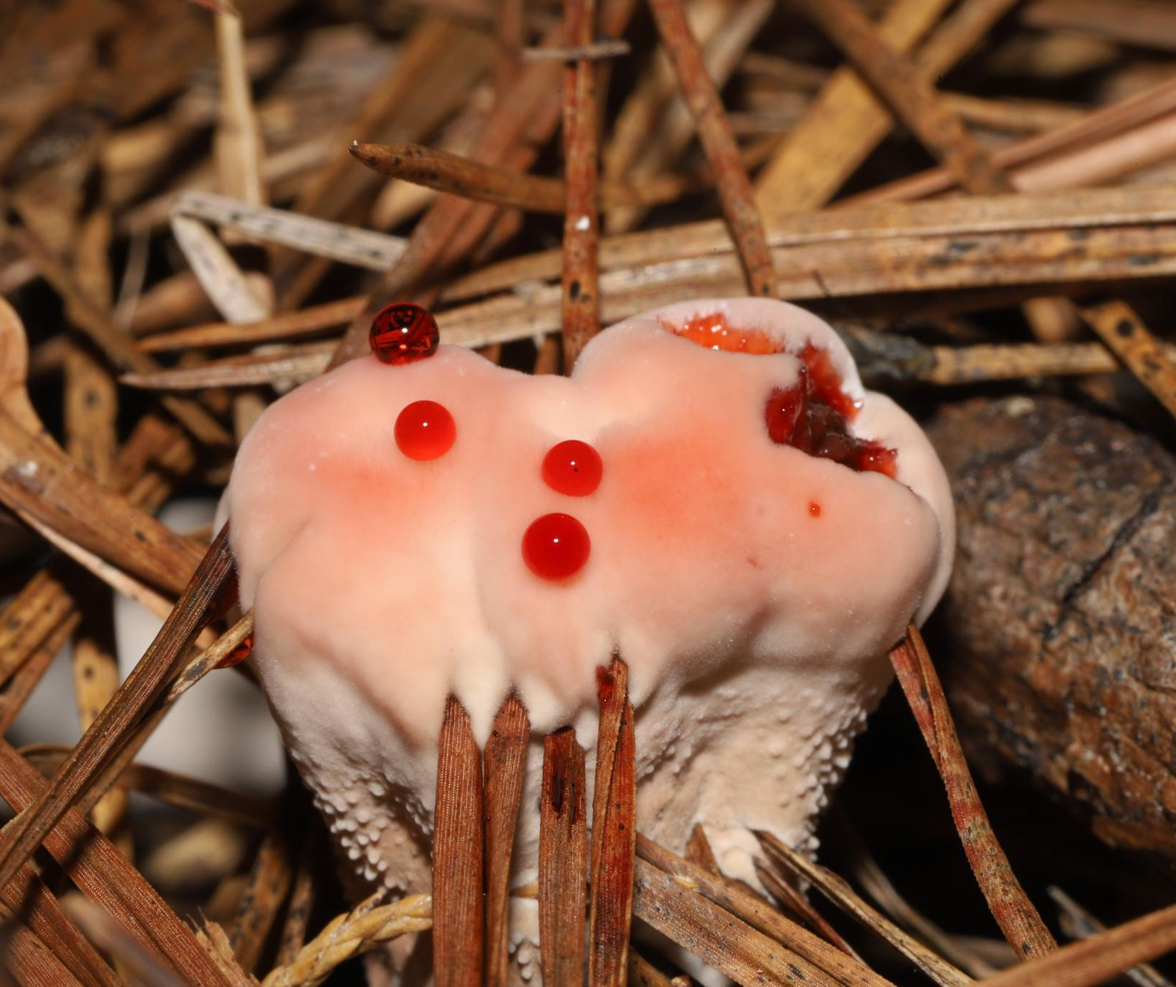
Go submit your own mushroom photos on October’s Calendar contest on Facebook!!
AMS Merch Now Available!
>Check it out now!<
Men and Womens and Kids T-shirts, baby onesies and hoodies now available!
Wearing AMS merch MIGHT attract the attention of renowned myco folks::
Alisha Millican, wearing our AMS shirt, with Bill Yule, Walt Sturgeon, and Jay Justice

In The Kitchen
By Kevin Hébert

Blue Oyster Miso Ramen with Bok Choy, Carrots, and Soft Boiled Eggs

This ramen recipe combines savory oyster mushrooms with fresh veggies and a creamy miso broth to create a delightful dish that's perfect for a cool October night.

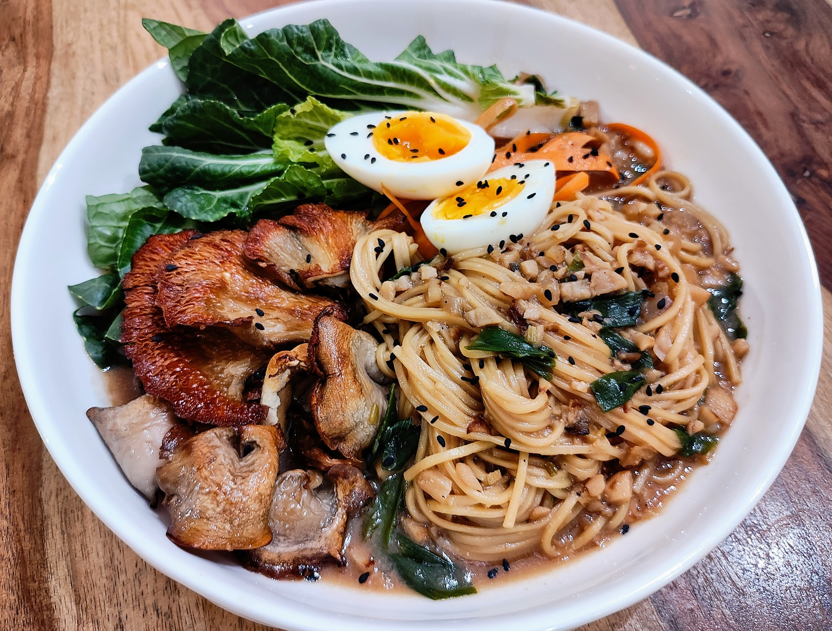

Ingredients (Makes 2-4 Servings):

1 large bunch of Blue Oyster Mushrooms (Pleurotus ostreatus var. columbinus)
1 bunch bok choy
1 bunch scallions
2 large carrots
3 farm eggs
6 oz dried ramen noodles
32 oz mushroom stock

4 tbsp white miso paste
¼ cup mirin
2 tbsp black sesame seeds
3 tbsp ginger
6 cloves garlic
3 cups spring water
canola or peanut oil
salt and togarashi
Directions:

Step 1: Prep the Ingredients
Preheat the oven to 425 degrees. Break the mushrooms into smaller clusters and separate the large stems from the caps. Small dice the stems. Brush the caps and smaller mushrooms with oil, sprinkle with salt, and place them on a parchment lined sheet tray. Remove the bottom ¾ of the bok choy stems and small dice them. Slice the bok choy leaves into ribbons. Peel the carrots into ribbons. Mince the garlic and ginger. Thinly slice the scallions and separate the green tops from the white bottoms. Put a small sauce pot on the stove and fill with water.

Step 2: Roast the Mushrooms and start the Miso Broth
When the oven is preheated, put the sheet tray of mushrooms in the oven and set a timer for about 12 minutes. In a medium to large stock pot, add a drizzle of oil and set the heat to medium high. When the pan is hot, add the diced mushroom and bok choy stems and saute for a few minutes until they begin to soften. Add the garlic, ginger, and white scallion bottoms and continue to cook for about 5 minutes. Add the miso paste and cook for another minute or so, then use the mirin to deglaze the pan. Add the mushroom stock and three cups of spring water. Bring the liquid to a boil, then reduce the heat to low and simmer. When the mushroom timer stops, turn them over and roast them for another 10 minutes or so until they are golden and crispy on the edges, then remove them from the oven and set them aside. Bring the small sauce pot to a medium boil.

Step 3: Cook the Ramen and soft boil the Eggs
After the broth has reduced a bit, add togarashi to taste. When and the flavor is where you want it, add the ramen noodles and maintain a low boil. Carefully add the eggs to the small sauce pot, and boil for 5-6 minutes depending on how runny you want your yolk. When done boiling, immediately remove the eggs and place them in an ice bath. Check your ramen for texture and when it reaches the desired texture, turn off the heat and stir in the green onion tops. Peel the eggs and slice them in half.

Step 4: Finish the dish
In large dinner bowls, portion out the roasted mushrooms, carrot ribbons, bok choy ribbons, and noodles. Pour the broth over the top of the vegetables and noodles and garnish with the soft boiled eggs and black sesame seeds. Mix it all together in the broth and enjoy!

FunDiS Southeast Rare Fungi Challenge!

Here are the Rare Fungi target species for our area! We will be pushing this hard and looking for folks to seek out these potentially rare species. A treasure hunt of the most exciting kind- fungi! Find details at https://fundis.org/protect/southeast
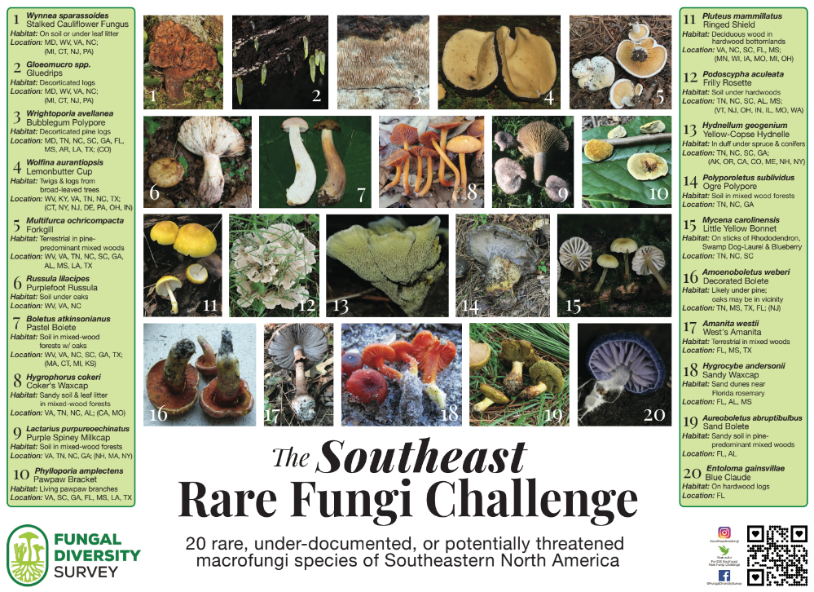

Meeting Information
No AMS Meeting for October due to the Alabama Mushroom Faire this week!
Please note! Meetings are done for the year and we will start back up in February.

2023 Scavenger Hunt
Have you heard about our scavenger hunt yet?! Find and properly identify as many mushrooms in Alabama as you can and win prizes at the end of the year! You get credit for finding the mushrooms when you add them to our project on iNaturalist. Read the full rules on our website here. Any observations you upload to iNaturalist will be automatically submitted to the project after joining. Joining the project is easy!
1. Download the iNaturalist app on your smartphone or access it via the website www.inaturalist.org.
2. Sign up for free to make your account.
3. Join the iNaturalist project titled “AMS 2022 Scavenger Hunt”
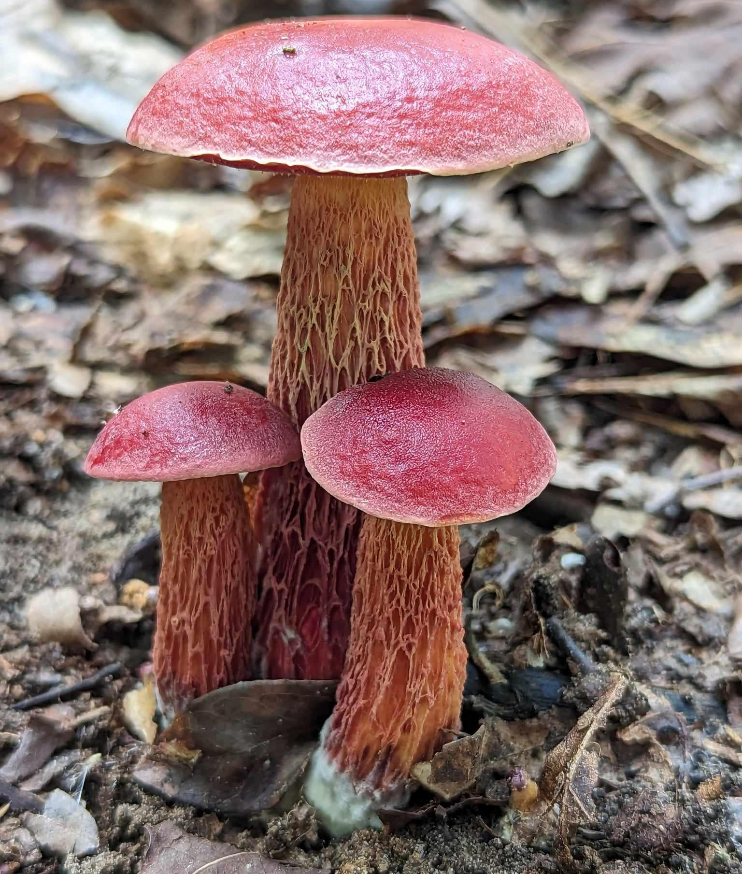
↠Must be a paid AMS member to win↞

Exeudoporus frostii
by Alisha Millican
Is there something you would like to see included each month? Do you have foray photos, a recipe or something else you would like to contribute? Reach out to us at www.almushroomsoc@gmail.com

