Alabama Mushroom Society Newsletter
August 2023
Greetings everyone!
I hope everyone is getting a chance to get out in the woods despite
the heat, and is doing so safely! Even with the heat advisory, we had a
marvellous time at the AMS colaborative event with the Alabama Nature
Journaling Club. We found some visually interesting fungi, learned a little bit
about them, and then ANJC leader Laramie Akozbek introduced us to some
AMS Board

President
Alisha Millican
Vice President
Jil Sea
Treasurer
Spencer Lowry
Secretary
Becca Mahoney
nature journaling promts and gave us pointers and encouragement as needed.
It was a great time and we were even joined by a photographer for the
Cullman Tribune!
We are having a special nighttime UV foray coming up on Aug 12. If
you didn’t hear about it or didn’t get a chance to sign up, it sold out SUPER fast.
Considering the amount of interest shown, we will definitely be doing another
one soon, so keep your eye out!
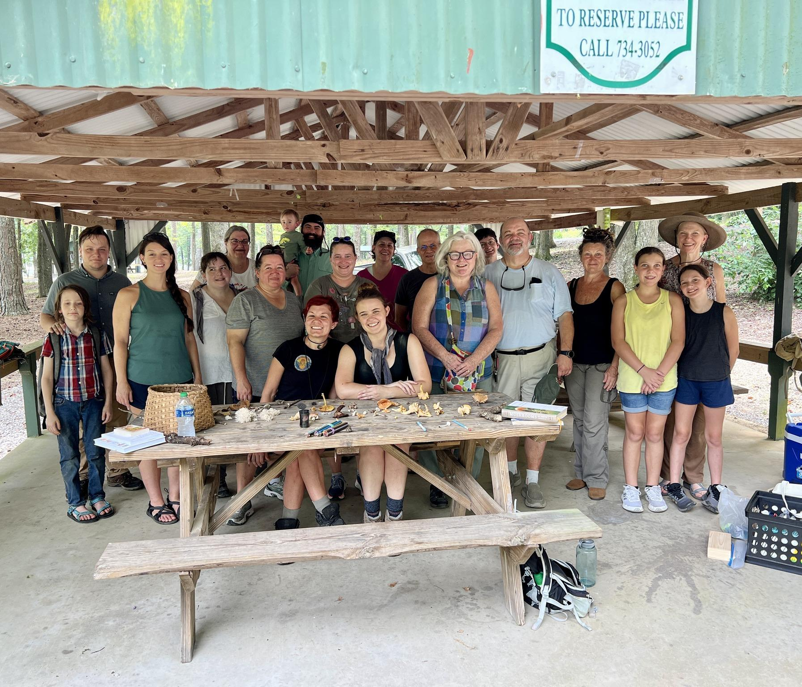
We are gearing up for the second annual Alabama Mushroom Faire!
Tickets are on sale now and if you would like to submit an application to be a
vendor, we are still taking them as well. Our schedule of events is finalized and
we will have an updated and pretty schedule up on the website soon!
We are so excited for all the presentations, demonstrations, forays and vendors
we have lined up! We are expecting an excellent turn out. If you haven’t got your
tickets yet, go get them HERE. Read about everything we have lined up on the
AMF page HERE.
Get out there, and I'll see you in the woods!
-Alisha Millican
AMS President

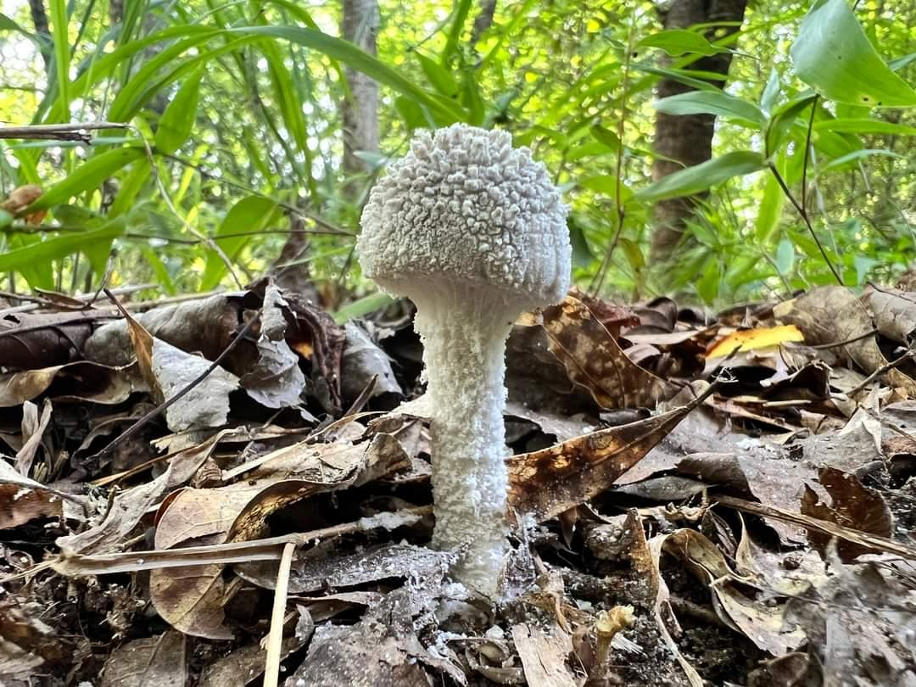
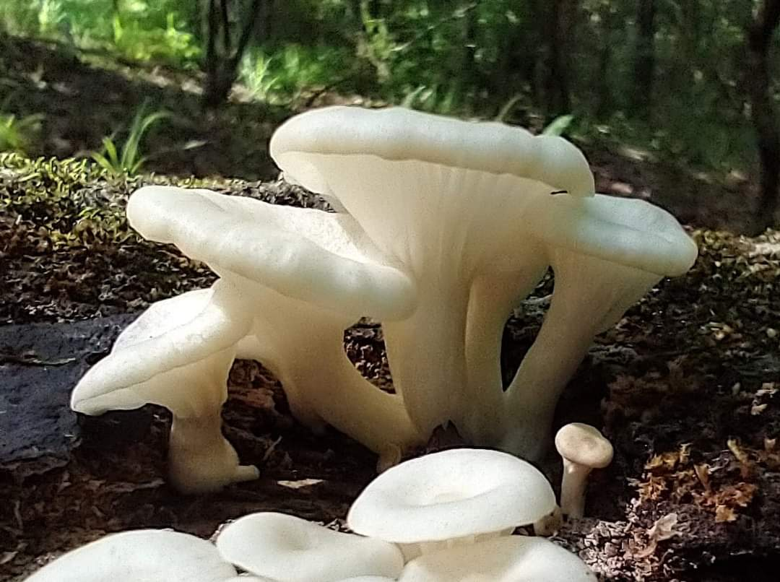

Amanita tephrea
By Mettie Weldon
Pleurotus pulmonarius
By Jan Newton

Upcoming Events
Click →HERE← for more info or to register for an event!
Aug 1st -----------------------------------------------------------------AMS Meeting via Zoom
Aug 3rd -----------------------------------------------------------------Virtual Tree ID with Feral Foraging
Aug 5th --------------------------------------------------------------- Jefferson County Monthly Foray
Aug 12th -------------------------------------------------------------- Baldwin County Monthly Foray
Aug 12th --------------------------------------------------------------- Nighttime UV Foray
Aug 19th --------------------------------------------------------------- Cullman County Monthly Foray
Aug 24-27th -----------------------------------------------------------NAMA Annual Foray
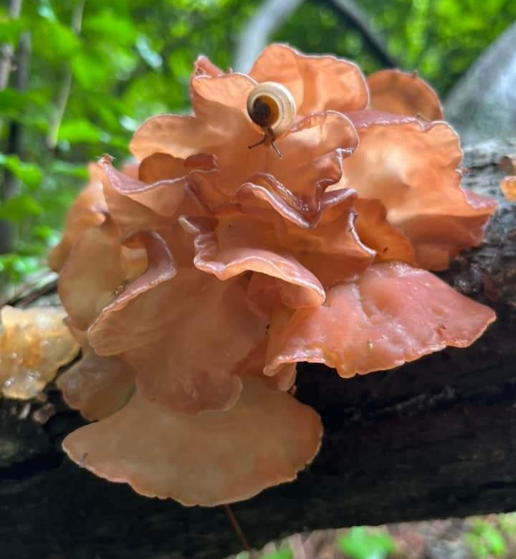

Auricularia species
By Ethan Hicks

Mushroom of The Month
Gomphus ludovicianus
By Kit King
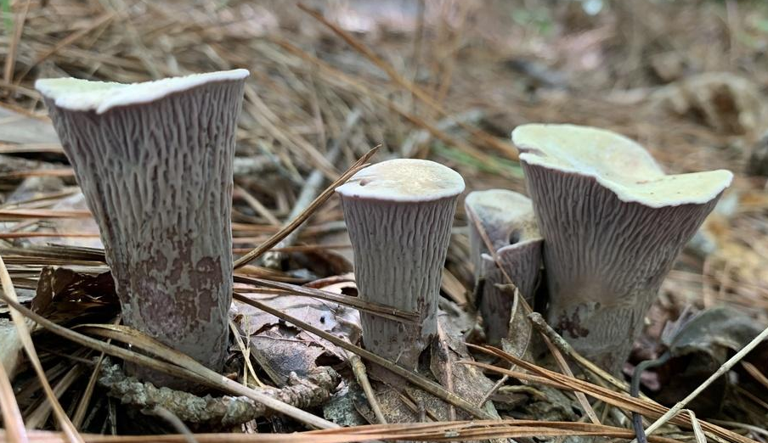
All photos credited to the author
Every year from mid August through September, the unusual fruiting bodies of Gomphus
ludovicianus emerge from the soil and push through the thick duff of our Southeastern forests.
These cantharelloid fungi are mychorrizal, often found growing among a mix of pine and hardwood trees. The young mushrooms are thumb sized and cork shaped, sporting a distinctive dusky lavender hue.

False gills, much like those associated with some species of Cantherellus, travel down their thick stipes. Older specimens grow quite large with fan shaped caps that are often made up of several fused, sprawling lobes. With age, the surface of the cap
may develop a buff color and become depressed in the center. The wrinkled, false gills become especially prominent as the fruit body develops.
G. ludovicianus is by no means a delicate mushroom during any stage of its development. Its stipe is thick and solid and its tissue is firm and dense. The lavender color of G. ludovicianus
muddies with age, but wherever beetles or larva penetrate its surface, the vibrant purple inner flesh is revealed. It is always fun to slice one of these mushrooms in half to observe the
characteristic purple tissue inside, which is brightest at the edges and fades to a lavender grey towards the center.

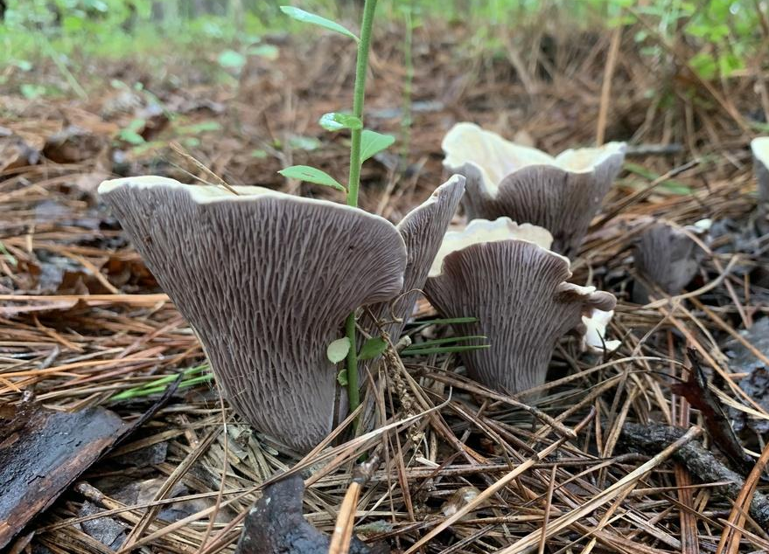
A large, healthy patch of G. ludovicianus is a beautiful sight in late summer. These mushrooms
often grow in clusters and it is not uncommon to find 5 or more individuals in one group.
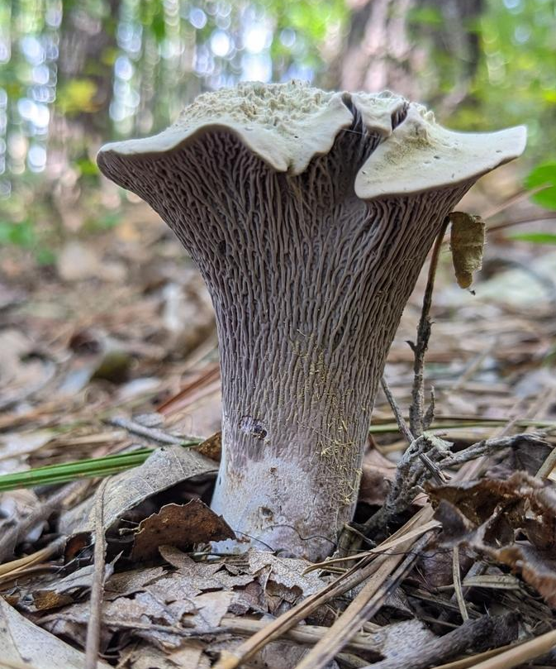
The first time I encountered them, I had no idea what I was looking at! The patch had all stages of
G. ludovicianus fruiting bodies, from newly emerged nubs to bug riddled giants. The unusual lavender color of the mushrooms and their distinctly wrinkled hymenium immediately reminded me of the large, fist sized chanterelles we find here in Alabama during the summer months. Not surprisingly, G.ludovicianus is often referred to by its common name, the Violet Chanterelle. It
also goes by the name Pig’s Ear mushroom, a nod to the floppy, buff colored pilei of older specimens.
G. ludovicianus is an edible mushroom, considered choice by many. Uncooked, it has a mild fruity scent and a spit test reveals a slight bitterness. Some consumers find this bitterness, which persist through cooking, to be undesirable. The flesh of the cooked mushroom is dense
and meaty with a slight crunch. Like all wild fungi , G. ludovicianus may cause mild stomach upset and other gastrointestinal issues in some individuals. It is always wise to start by eating a small amount of well cooked mushrooms to determine your personal sensitivity the first time
you eat a new species.
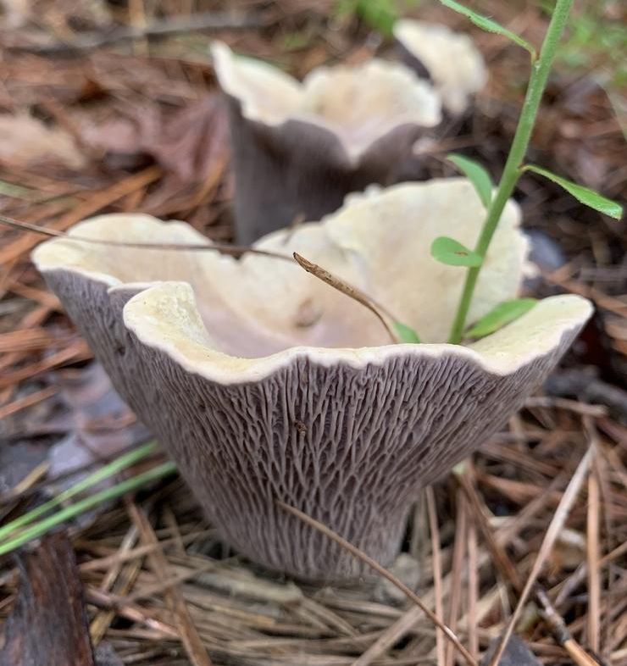
Until recently, all North American Gomphus species were believed to be Gomphus clavatus.
Observations of the fungi were mainly reported from western states but there was very little information on Gomphus occurring in the Southeast. Through DNA sequencing, mycologists have been able to differentiate North America’s Gomphus ludovicianus from the previously described European species, G. clavatus. Although it is often considered uncommon, it is more likely that G. ludovicianus is actually just
under-observed. Despite its purple hue, it is easily overlooked and blends in well with the forest floor. Some fruiting bodies may become trapped under dense leaf litter, creating mounds in the duff with a mushroom barely peeking through. Keep your eyes peeled as you walk through the woods this summer and you may be rewarded with a sighting of this beautiful and unusual mushroom in the next few weeks. If you are lucky enough to come across these beauties, please document your find on iNaturalist.org and share your photos to our facebook page!

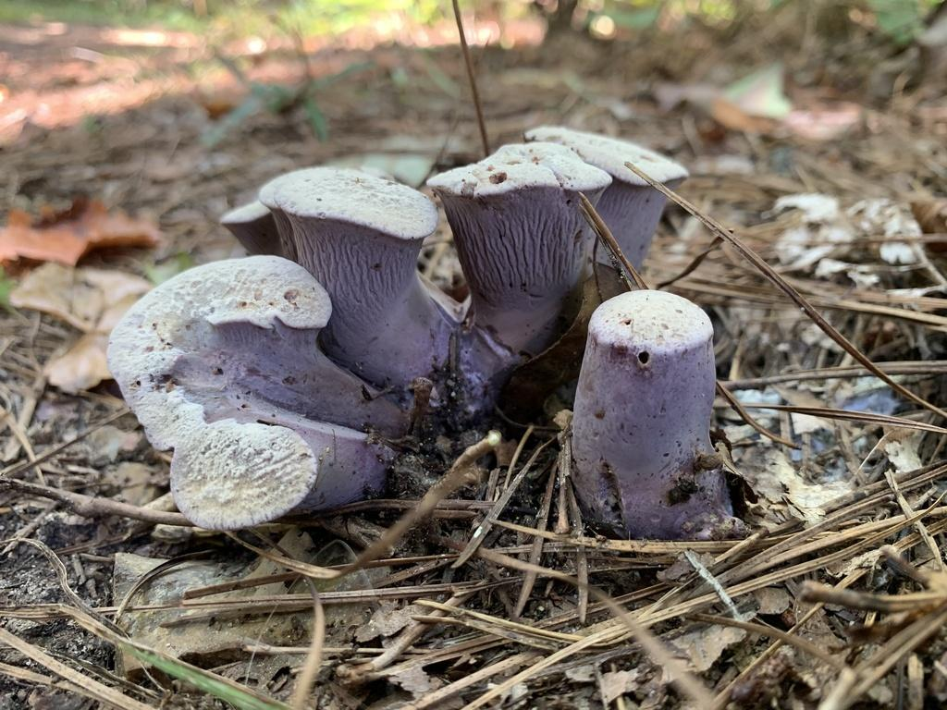

Fungi Foragecast
By Anthoni Goodman
As we move into August, rains continue to determine our mushroom hunting
success. A good rain map will be your key for determining the best locations for
a good forage. We continue to see a wide array of Summer mushrooms throughout Alabama.
This is a great time to be getting out and taking those fantastic photos to post to
iNaturalist and documenting what our great state has to offer! Seriously, we've
seen amazing photography lately!
Craterellus, the Chanterelles and Craterellus, the Black Trumpets have both been going strong. The latter can be tricky to spot with their dark coloration. Here is a tip: hunt them using a bright flashlight, they have a bit of iridescence when the light hits them that can make them
easier to spot. Hunt them in areas where moss grows. Like chanterelles, they
like some sand. Our boletes are still coming in in full force. These mushrooms have pores
instead of gills (well, most of them) and are mycorrhizal with trees. The first
question in most bolete identification keys is "what trees is it growing under" so
pay attention when picking these guys if you want to ID it later. We've had
several reports of Strobilomyces (Old Man of the Woods), some Suilius species,
many of the bitter Tylopilus , Xerocomellus, Hortiboletus, and a whole ton of
Retiboletus.
Remember that for bolete identification help, you should provide clear photos of
the stem, cap from above and below, a bisected specimen photo, a report of
smell and taste. There are some overlapping features that may also require a
chemical test (a drop of KOH, ammonia, or iron salts).
Out in the woods, keep an eye out for Pluteus, Russula, Lactarius (including L.
indigo the indigo milkcap) and Lactifluus. Armies of Amanita will arise,
especially A.'s amerirubescens, arkansa, banningiana, bisporigera, flavoconia,
flavorubes, jacksonii, murrilliana, onusta, praecox, rhacopus, vaginata,
virginiana, and westii. You may notice I've left out the lepidellas, and while we
will certainly see some of them, they have a greater propensity to fruit in the fall.
I urge caution and copious education to anyone foraging any Amanita for the
table as several Amanita species will kill you quite painfully if eaten - this is NOT
a beginners genus for consumption. Though even the most deadly mushrooms
can very safely be handled.
Corals have also been out and include such as Artomyces, Ramaria,
Ramaropsis, and Clavulina.
As the humidity keeps up, also look for fungally parasitized insects and spiders.
Don’t forget to post your cool and unusual finds both on our Facebook group
and on iNaturalist!

Calendar Contest
Congratulations to our July winner Eric Van Nostrand with his photo of Exseudoporus frostii taken in Shelby County!

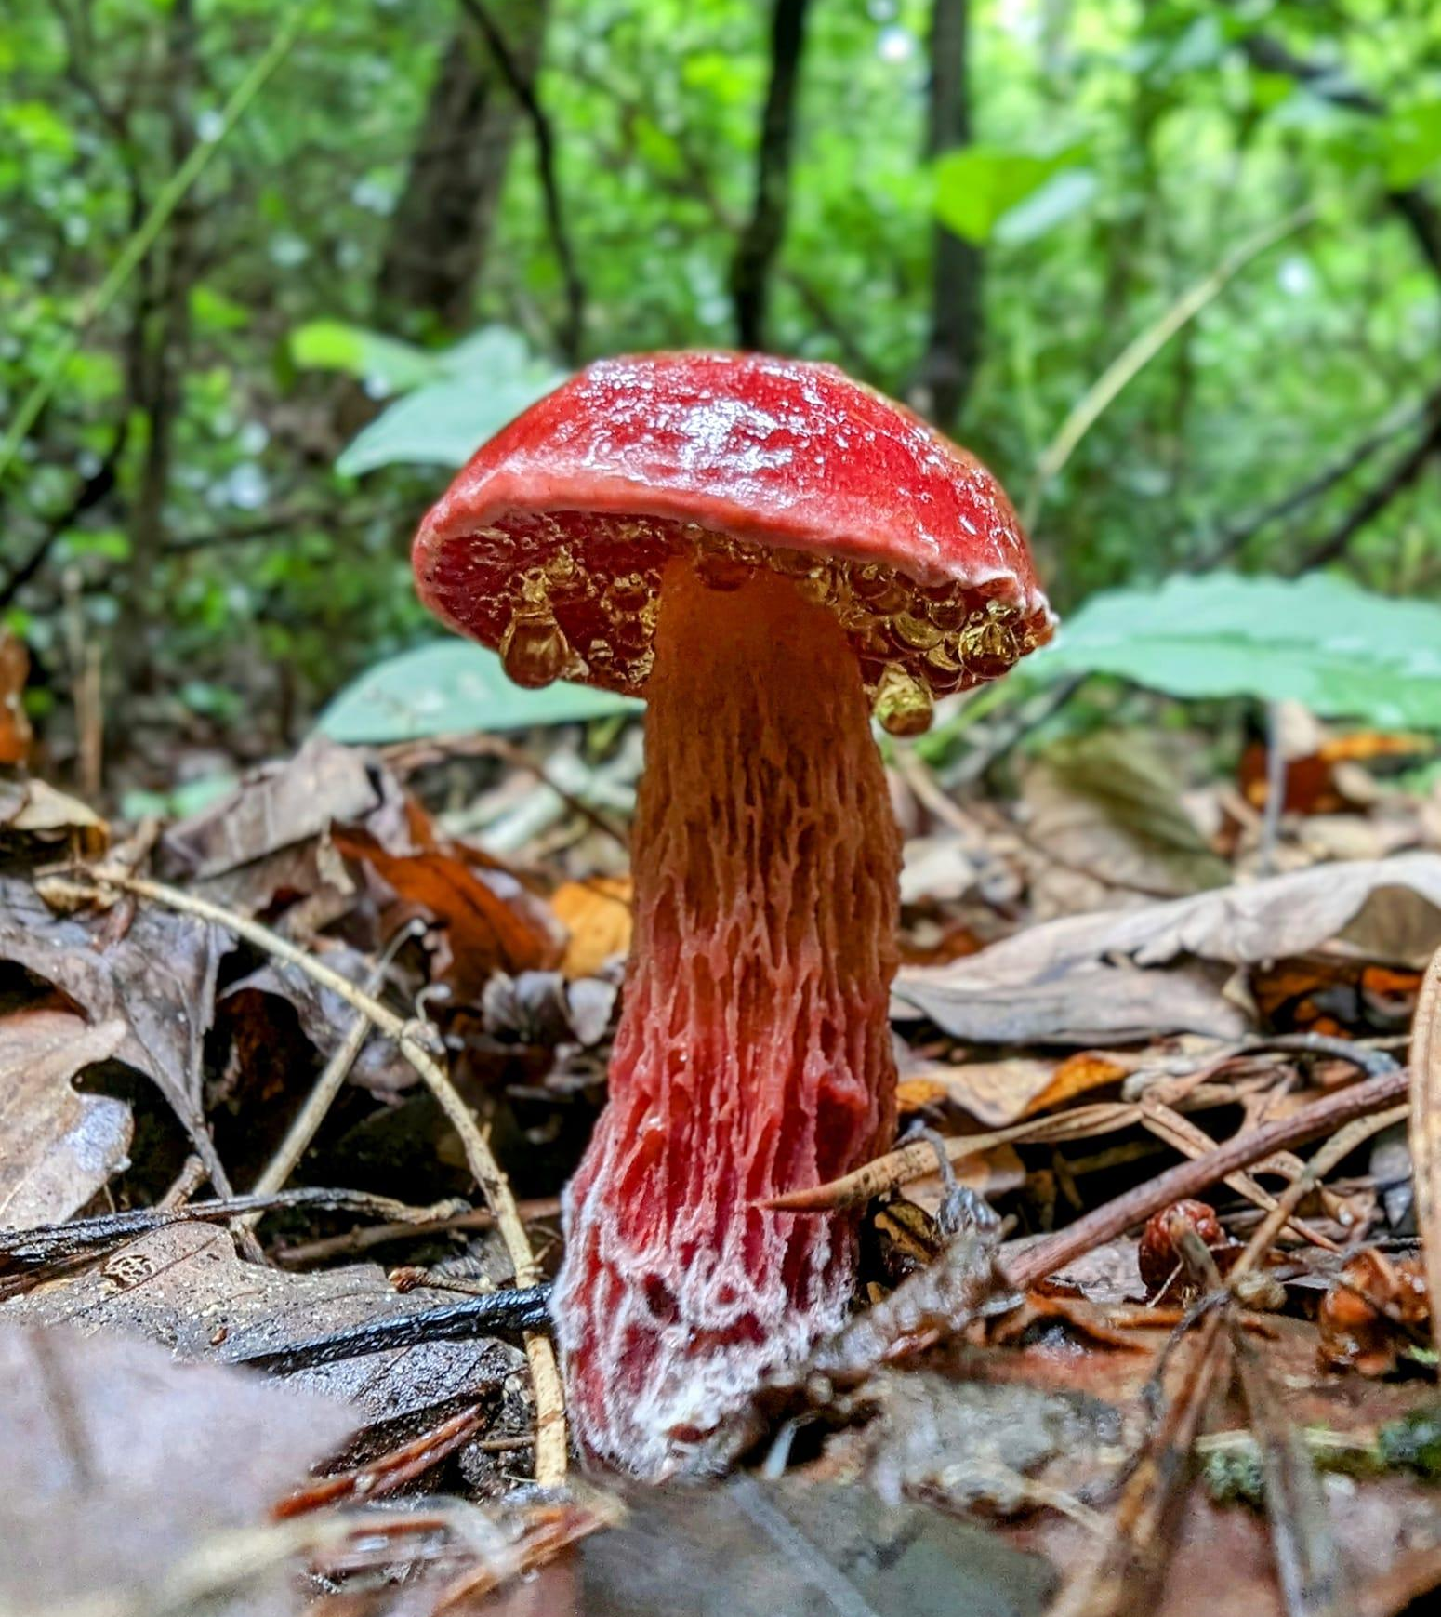
Go submit your own mushroom photos on Aug’s Calendar contest on Facebook!!
AMS Merch Now Available!
>Check it out now!<
Men and Womens and Kids T-shirts, baby onesies and hoodies now available!
Wearing AMS merch MIGHT attract the attention of renowned myco folks::
Alisha Millican, wearing our AMS shirt, with Bill Yule, Walt Sturgeon, and Jay Justice

In The Kitchen
By Kevin Hébert

Crispy Lactifluus "Fish" Tacos with Squash Jalapeño Slaw, Fresh Pico, Hot Avocado Crema and Sweet Corn Salad

It's Fish Cap season again! This crispy taco recipe is packed with flavor that will make you want to start following your nose more in the woods. These mushrooms are beer battered and fried then topped with garden fresh squash, tomatoes, jalapeños, onions and cilantro to brighten up your Tuesday night special. A jalapeño blended avocado crema adds some heat and pairs nicely with this street food style sweet corn salad.

Ingredients (Makes 2-3 Servings):

Tacos and Beer Batter:
10-20 Fresh Fish Caps
(Lactifluus Volemus and/or Corrugis)
Whole wheat tortillas
1 ½ cup Corn starch
2 cups AP flour
1 tsp baking soda
1 ½ cup Dark Mexican beer
Avocado Crema:
2 ripe avocados
¼ cup nonfat Greek yogurt
¼ cup low fat sour cream
1 tbsp jalapeño
2 tbsp diced onion
3 tbsp lime juice
1-2 cloves garlic
1 tsp salt
Fresh Pico:
2 medium tomatoes
2 tbsp onions
1 tbsp jalapeños
1 tbsp lime juice
2 tsp cilantro
1 clove garlic
½ tsp salt
Squash Jalapeno Slaw:
1 medium yellow squash
1 tbsp jalapeños
½ tbsp lime juice
1 tsp oil
½ tsp salt
Sweet Corn Salad:
4 cups of cooked sweet corn
1 tbsp mayonnaise
1 tbsp low fat sour cream
½ tbsp lime juice
½ tsp chili powder
½ tsp paprika
½ tsp salt
½ cup queso fresco
2 thinly sliced green onions
1 tbsp cilantro, more to taste
Directions:

Step 1: Prep the ingredients and make the beer batter

Add the 2 cups flour, baking soda, and 1 cup cornstarch to a medium bowl and mix together (you can also add a little salt and garlic powder if you want). Save ½ cup cornstarch for dusting the mushrooms. Slowly whisk in the beer until the texture is like a thin pancake batter. Cover and set aside in the fridge for 15-30 minutes. Soak the mushrooms in a bowl of salted water for about 15 minutes. This will help remove some of the latex and flush out any bugs. They will smell fishy, so I usually cover the bowl. After soaking, lay the mushrooms out on a cloth to dry. Slice the mushrooms into bite sized pieces. Small dice the onions, tomatoes, shallot, jalapenos. Remove the avocado from the shell. Grate the squash on a cheese grater. Remove the corn from the cob. Crumble the queso fresco. Pick the cilantro leaves, and finely chop the stems. Thinly slice the green onions.

Step 2: Make the Squash Jalapeno Slaw, Pico, and Avocado Crema

In a small bowl add grated squash, diced jalapenos, lime juice, oil, and salt. Stir to combine, cover and set aside. In another small bowl add diced tomatoes, onions, and jalapenos with minced garlic, lime juice, cilantro stems, and salt (mix in the cilantro leaves right before serving). Stir to combine, cover and set aside. For the crema, add the avocado, jalapeno, onion, yogurt, sour cream, lime juice, garlic, and salt into a blender or food processor and pulse until smooth. Add a splash of water to reach the desired drizzling texture. Pour into a small bowl, cover, and set aside until ready to serve.

Step 3: Make the Sweet Corn Salad

Remove cooked corn from the cob if necessary. In a bowl, mix together the mayo, sour cream, green onions, chili powder, paprika, and salt. Mix in half of the queso fresco and reserve the other half to sprinkle on top. Stir the corn into the bowl with the prepared dressing, then garnish with remaining cheese and cilantro.

Step 4: Fry the Mushrooms and build the Tacos
While you are preparing the taco toppings, heat a pan of frying oil (I use peanut oil) to 365 degrees. Remove the beer batter from the refrigerator. Coat all of the mushrooms in a base layer of corn starch and let them sit for a few minutes. When the oil is hot, dip the mushrooms into the beer batter then into the fryer. A fry basket works well if you have one. Fry the mushrooms for around 3-5 minutes or until crispy and golden. At this point, your kitchen will smell like you are at a fish fry (in a good way). Remove the mushrooms from the oil and place them on a draining rack or towel. When the mushrooms are cooled slightly, warm the tortillas and build the tacos with the crispy mushrooms, pico, slaw and crema, and serve the corn salad on the side. Top it all off with any remaining cilantro and queso fresco, then enjoy!
FunDiS Rare Fungi Challenge
Keep an eye out in the next couple weeks as FunDiS is preparing to launch the Rare Fungi target species for our area! We will be pushing this hard and looking for folks to seek out these potentially rare species. A treasure hunt of the most exciting kind- fungi!

Meeting Information
AMS meetings place the first Tuesday of the month at 7pm CST via Zoom and are open to the public.
Join us Aug 1st where, after a brief business meeting, we will be joined by Emma and Gabe of Gowin Valley Farms who will be talking to us about At Home Mushroom Cultivation! If you have ever wanted to start growing your own mushrooms, this is the presentaion for you! Dont miss out! As always, the recording will be available to paid AMS members via the Members Lounge on the website.

Link to the zoom meeting: Join Meeting
Meeting ID: 853 3006 6060
Passcode: 18

2023 Scavenger Hunt
Have you heard about our scavenger hunt yet?! Find and properly identify as many mushrooms in Alabama as you can and win prizes at the end of the year! You get credit for finding the mushrooms when you add them to our project on iNaturalist. Read the full rules on our website here. Any observations you upload to iNaturalist will be automatically submitted to the project after joining. Joining the project is easy!
1. Download the iNaturalist app on your smartphone or access it via the website www.inaturalist.org.
2. Sign up for free to make your account.
3. Join the iNaturalist project titled “AMS 2022 Scavenger Hunt”
↠Must be a paid AMS member to win↞
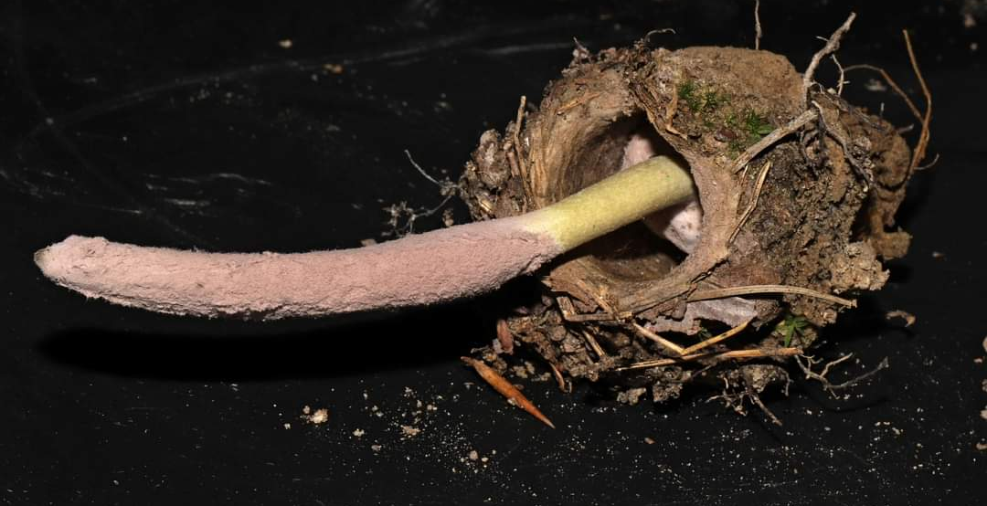
Purpureocillium atypicola parasitizing a trap door spider
By Flown Kimmerling
Is there something you would like to see included each month? Do you have foray photos, a recipe or something else you would like to contribute? Reach out to us at www.almushroomsoc@gmail.com
Photo by
Beth Lasseter High

