Alabama Mushroom Society Newsletter
September 2023
Greetings everyone!
The summer is zooming by and I hope you are getting a chance to get
out into the woods!
The season for fungi faires is upon us. We had a magnificant time at
the 2023 Annual NAMA foray in Hendersonville, NC. We will be sharing a
recap by AMS Scholarship winner Bucky Reader in next months newsletter
about his first NAMA experience.
The Georgia Mushroom Festival is coming up at the end of this month.
Stop by and say hi to us at our booth over in the Vender Villiage. Poisons FB Group
AMS Board

President
Alisha Millican
Vice President
Jil Sea
Treasurer
Spencer Lowry
Secretary
Becca Mahoney
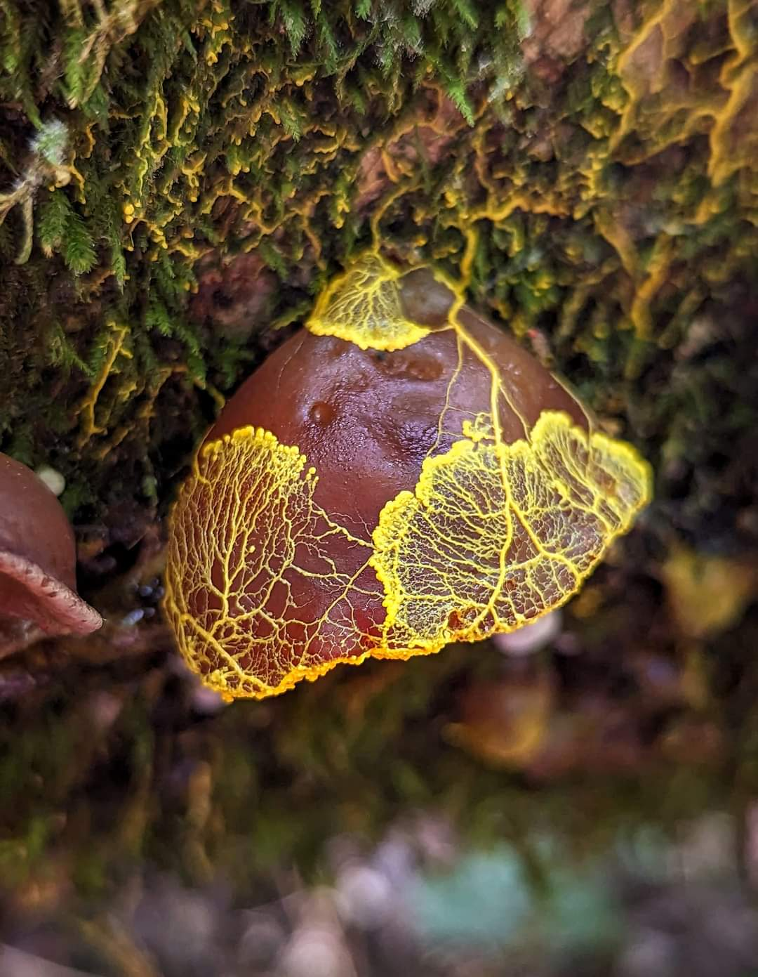
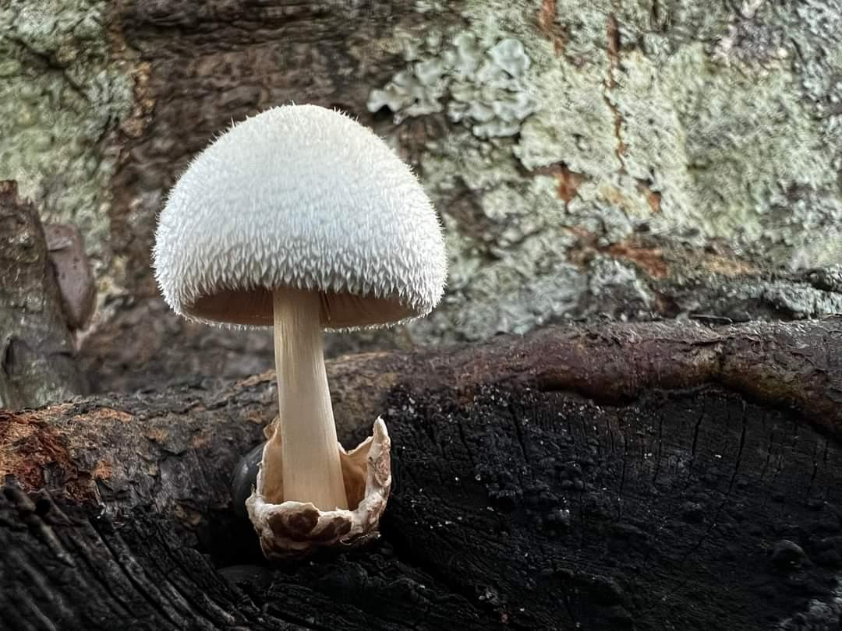
Our very own second annual Alabama Mushroom Faire is coming up
quick! October 7-8 in Battleground, Alabama, just outside Cullman. Tickets are
on sale now and if you would like to submit an application to be a
vendor, we are still taking them as well. Our schedule of events is finalized and
we have a SUPER exciting line up of presentations and demos by some of the top
mycologists and experts in the US! There will be activities for all ages and interest
levels! We are expecting an excellent turn out. If you haven’t got your
tickets yet, go get them HERE. Read about everything we have lined up on the
AMF page HERE.
Get out there, and I'll see you in the woods!
-Alisha Millican
AMS President

Volvariella bombycina by Jonathon Cendi Stevens
Auricularia with slimemold by Kristi Zoebelein
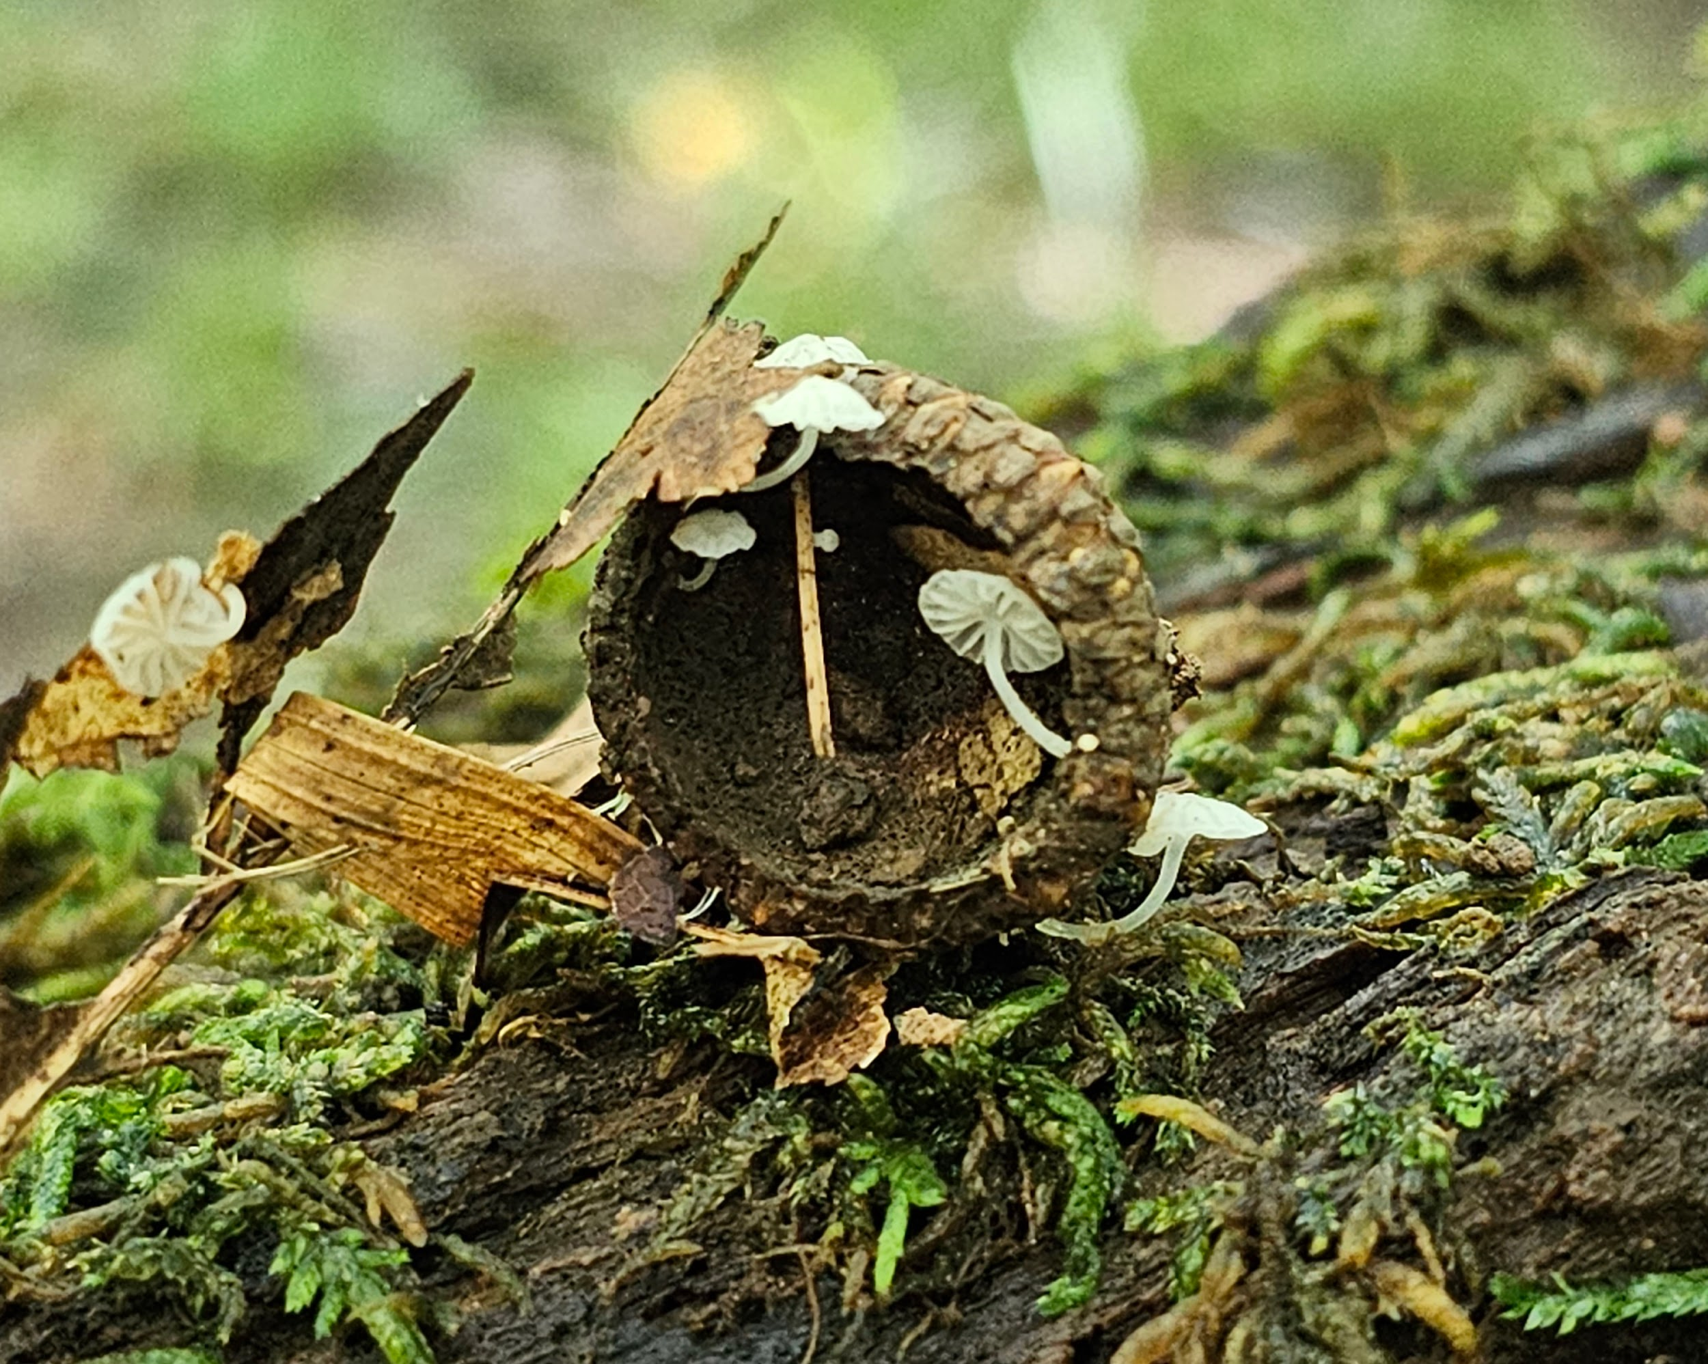
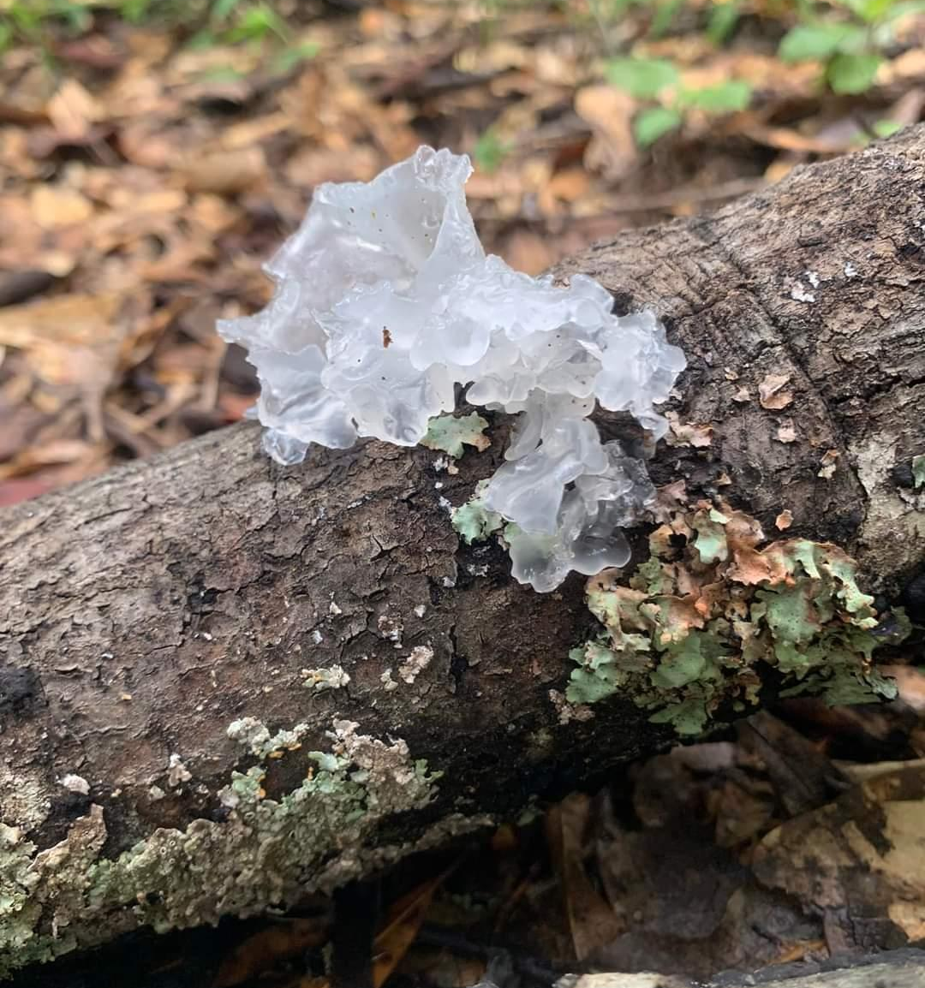

Tremella fuciformis by Joshua D Sorrow
Delicatula integrella by Leigh Maness

Upcoming Events
Click →HERE← for more info or to register for an event!
Sept 5th -----------------------------------------------------------------AMS Meeting via Zoom
Sept 9th --------------------------------------------------------------- Jefferson County Monthly Foray
Sept 9th --------------------------------------------------------------- Cullman County Monthly Foray
Sept 9th --------------------------------------------------------------- Baldwin County Monthly Foray
Sept 16th --------------------------------------------------------------Elmore County Monthly Foray
Sept 17th --------------------------------------------------------------Madison County Monthly Foray
Oct 7-8th --------------------------------------------------------------Alabama Mushroom Faire
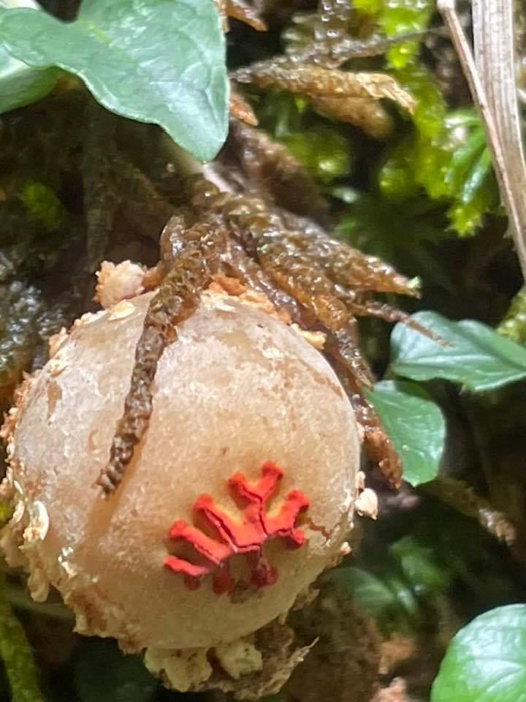
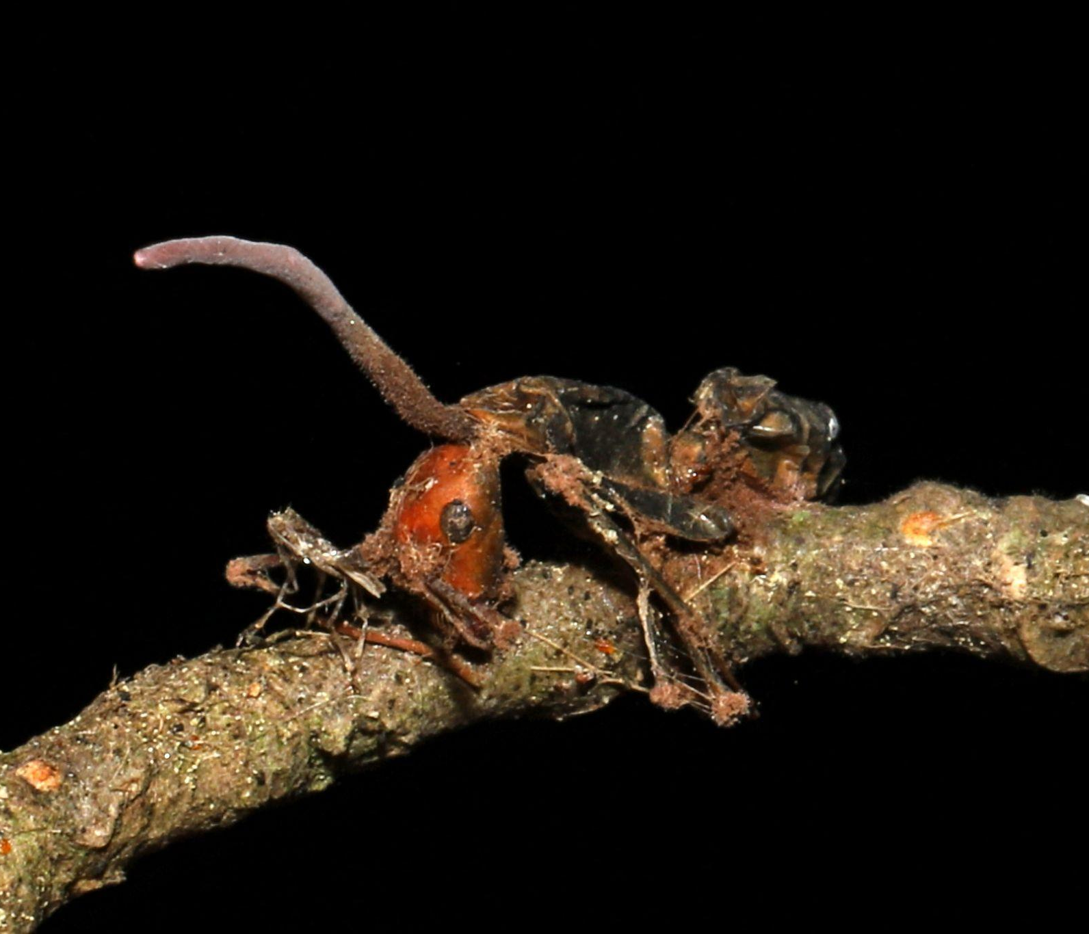

Ophiocordeceps kimflemingiae by Flown Kimmerling
Calostoma by Brent Holman
Mushroom of The Month
Tremella fusciformis
By Kit King
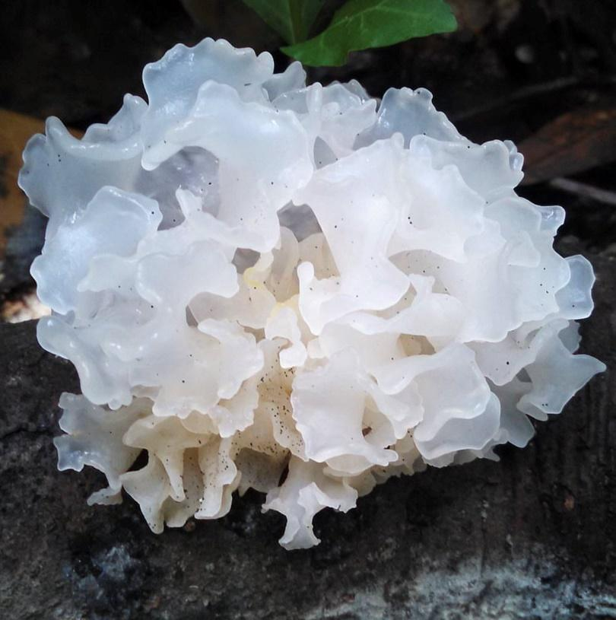
All photos credited to the author
A luminous jewel of a mushroom, Tremella fuciformis occurs on dead hardwood branches in the damp, dark woods of our southern forests and throughout the tropics. Emerging after heavy rains in summer and fall, the fungus is easily identified by its translucent white fronds and firmly gelatinous texture. The foliose structure of its fruiting body is reminiscent of seaweed. It can be quite large when fresh, nearly fist sized, and is easily spotted at this stage due to its size and milky white glow. It’s not hard to understand how this mushroom got its common name: the Snow Fungus.
During dry weather, the Snow Fungus takes on a tea-colored hue and begins to shrivel. The lovely, plump fronds become thin and brittle as the fruiting body desiccates. When the next soaking rain comes, the mushroom will rehydrate but it will never fully recover the splendor of its original state.
A freshly picked Snow Fungus does not have a distinguishing taste or smell. Its watery texture is slippery with a light and pleasant crunch. It has been a popular edible mushroom in numerous Asian countries for centuries, where it is commonly eaten as a desert. In one version of this dish, fresh or rehydrated Snow fungus is submerged in a lightly sweetened syrup and is served as a cold and refreshing soup.
Tremella fuciformis is a complex organism. A dimorphic fungus, it can transition between two phases, existing either as a single celled yeast or as a multicellular fungus, complete with hyphae. The transition between these two phases is influenced by its parasitic relationship with fungi in the genus Annulohypoxylon. These hard, dry fungi commonly appear as black balls or bumpy crusts on decaying hardwood.
T. fuciformis begins its lifecycle as a parasitic yeast, manifesting as a thin, nondescript slime. It continues in this phase until it comes in contact with its host. In association with certain species of Annulohypoxylon, T. fuciformis can access the nutrients it needs to transition into its multicellular phase. This transition is characterized by rapid mycelial growth that ultimately leads to the formation of the glistening white fruiting body we are familiar with.
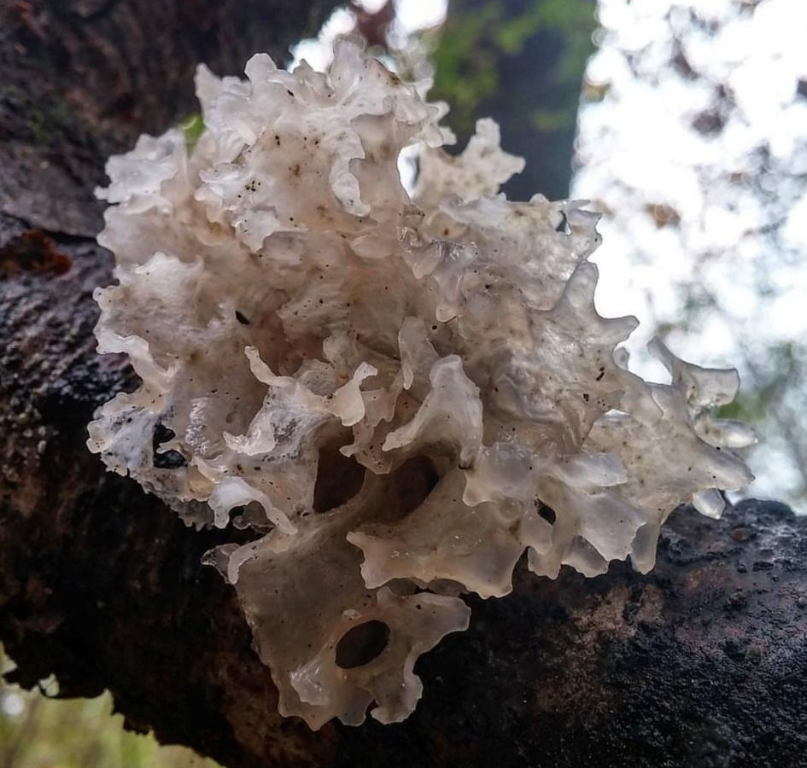
Like all species of Tremella, T. fuciformis is a mycoparasite. However, its relationship with its host is not entirely understood. Annulohypoxylon fungi are saprobes, releasing enzymes which digest the dead wood on which they grow. Perhaps T. fuciformis simply scavenges for nutrients while its host does the work of producing enzymes. Or maybe T. fuciformis directly parasitizes the mycelium of its host. It is also possible that the relationship is communalistic rather than traditionally parasitic. More research is needed to fully understand the interactions between these companion fungi.

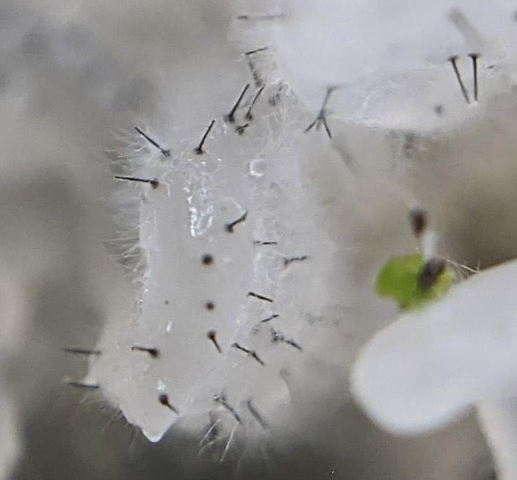
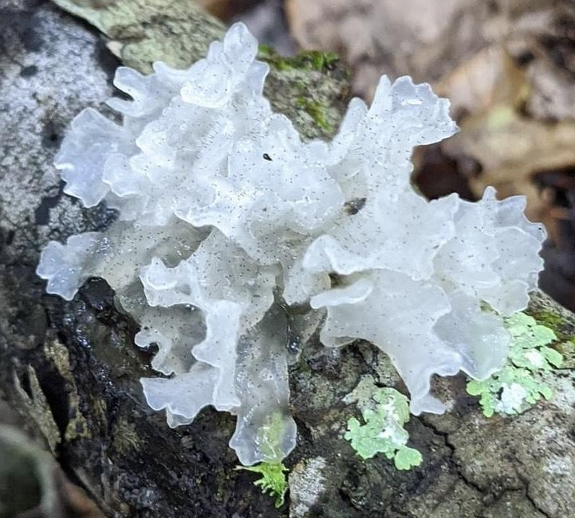
The complexity of this mushroom and its relationship with other fungi is further complicated by the fact that Tremella fuciformis, a mycoparasite itself, actually has a parasite of its own! Next time you find a fresh snow fungus, take a closer look and you may see the tiny, black, pin shaped fruiting bodies of Sporothrix epligloea. Like T. fuciformis, Sporothrix epigloea is also dimorphic and can transition between a single celled, yeast like fungus and a multicellular fungus with a mycelial network. The polysaccharide rich basidiocarp of T. fuciformis provides S. epigloea with the nutrients it needs to complete its transition from a soil dwelling yeast to a multicellular fungus capable of developing a fruiting body.

The complicated relationship between Tremella fuciformis and its fungal companions is a delightful reminder that we have only scratched the surface of our understanding of the mushroom realm. The intricate microbial interactions that take place all around us drive the cycles of decay and renewal required to sustain life on our planet. While we may never fully comprehend the complexities of these relationships, each new discovery offers us more insight into the interconnectedness of all living things.
Fungi Foragecast
By Anthoni Goodman
As always, rains continue to determine our mushroom hunting success. A good rain map will be your key for determining the best locations for a good forage. This map is my go-to.
We continue to see a wide array of Summer mushrooms throughout Alabama. No sign of the fall species popping up just yet, but we can expect to start seeing them probably later this month, like Desarmillaria caespitosa and Grifola frondosa
The recent rains over some of the state have reignited the Chanterelles and the trumpets! If you had given up checking your spots, you might venture back out. Chanterelles will continue to pop up as long as you are getting rain until the ground temperatures drop.
We are still seeing our Boletes coming in in full force. These mushrooms have pores instead of gills (well, most of them) and are mycorrhizal with trees. The first question in most bolete identification keys is "what trees is it growing under" so pay attention when picking these guys if you want to ID it later. We've had several reports of Strobilomyces (Old Man of the Woods), some Suilius species, many of the bitter Tylopilus , Xerocomellus, Hortiboletus, and a whole ton of Retiboletus . Here is a link to the newest bolete book, which will certainly help you out with IDing these guys: Boletes of Eastern North America Remember that for bolete identification help, you should provide clear photos of the stem, cap from above and below, a bisected specimen photo, a report of smell, taste and any bruising, both immediately and after several minutes and what trees are growing nearby. There are some overlapping features that may also require a chemical test (a drop of KOH, ammonia, or iron salts).
Out in the woods, keep an eye out for Pluteus, Russula, Lactarius (including L. indigo the indigo milkcap) and Lactifluus. We are seeing armies of Amanita, especially A.'s amerirubescens, arkansa, banningiana, bisporigera, flavoconia, flavorubes, jacksonii, murrilliana, onusta, praecox, rhacopus, vaginata, virginiana, and westii. You may notice I've left out the lepidellas, and while we will certainly see some of them, they have a greater propensity to fruit in the fall. I urge caution and copious education to anyone foraging any Amanita for the table as several Amanita species will kill you quite painfully if eaten - this is NOT a beginners genus for consumption. Though even the most deadly mushrooms can very safely be handled.
Corals have also been out and include such as Artomyces, Ramaria, Ramaropsis, and Clavulina.
As the humidity keeps up also look for insects and spiders parasitized by fungi! If you find any- we have a few that we are collecting for researchers. See our list on facebook HERE.

Calendar Contest
Congratulations to our August winner Charlotte Baker with her photo of Xylaria magnoliae taken in Chambers County!

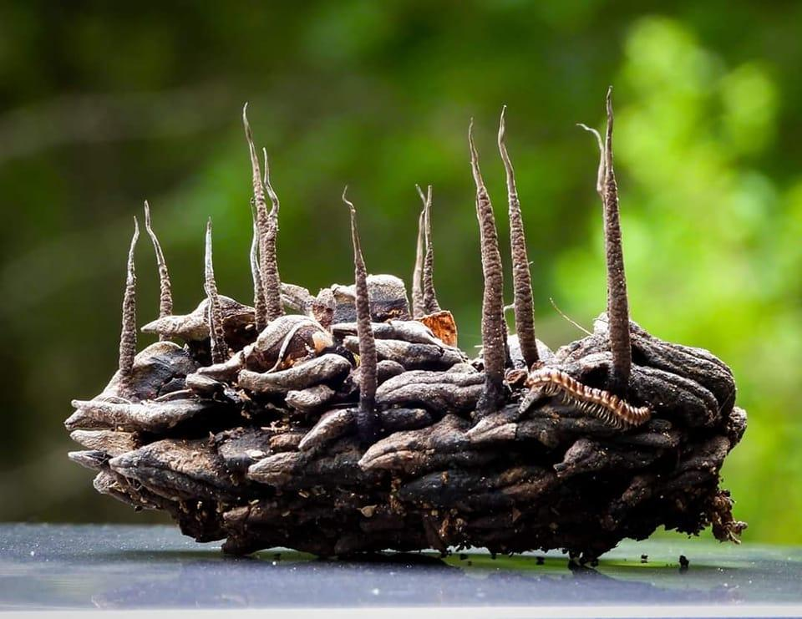
Go submit your own mushroom photos on Sept’s Calendar contest on Facebook!!
AMS Merch Now Available!
>Check it out now!<
Men and Womens and Kids T-shirts, baby onesies and hoodies now available!
Wearing AMS merch MIGHT attract the attention of renowned myco folks::
Alisha Millican, wearing our AMS shirt, with Bill Yule, Walt Sturgeon, and Jay Justice
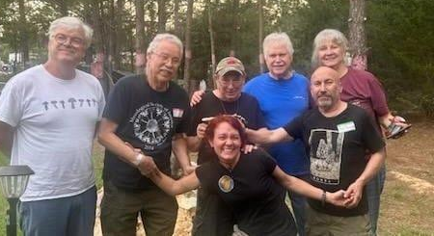

In The Kitchen
By Kevin Hébert

Mane Lion Roll with Spicy Crab-Boiled Potatoes

The weather is cooling down, and the lion’s mane is going to start popping up in your favorite spots (or you can just grow it on your counter like I do). This easy recipe is a play on a traditional new england-style lobster roll, with a side of spicy louisiana-style boiled red potatoes.

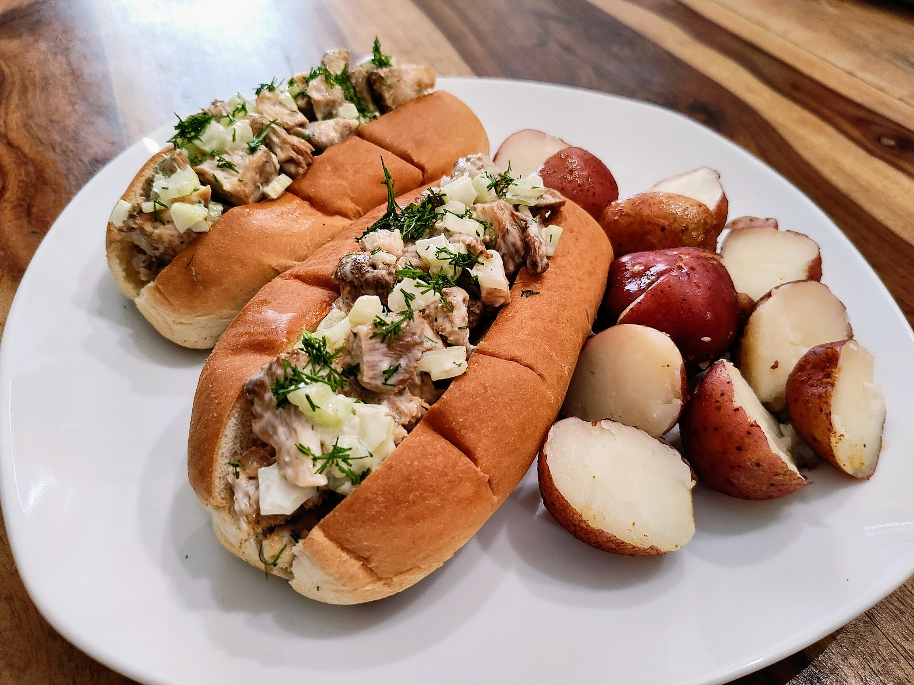

Ingredients (Makes 2 Servings):

16 oz fresh Lion’s Mane (hericium sp.)
4 New England style hot dog buns
½ bag of red potatoes
4 ribs celery
4 fresh dill fronds
3 scallions
6 cloves garlic

1 cup mayonnaise
1 lemon
4 oz butter
1 boil-in-bag packet of crab boil
salt
pepper

Directions:

Step 1: Prep the ingredients
Set the oven to 425 degrees. Cut the mushroom into ½ inch cubes. Slice the celery stalks into half inch pieces and roughly chop the dill fronds. Thinly slice the green onions. Mince the garlic. Slice the lemon in half. Wash the potatoes. Melt the butter.

Step 2: Boil the Potatoes and Roast the Mushrooms
Add a medium pot of water to the stove on high and lightly salt the water. When the water begins to boil, add the crab boil seasoning bag. Let the water continue to boil with the bag for about 15 minutes. Stir the water but be careful not to break the boil bag. When your eyes start burning from the spicy air in the room, add the potatoes, whole garlic cloves, and half the lemon to the boiling water and continue stirring gently until the potatoes are easily pierced with a fork. Strain the potatoes and the garlic cloves and set aside. While the potato boil is heating up, toss the cut lion's mane with melted butter and a dash of salt (save some butter for the buns). Add to a sheet tray and place in the oven for 10-15 minutes, or until you start to see the edges get lightly crispy. Remove the mushrooms from the oven and set aside to cool.

Step 3: Make the Mushroom Mixture
When the mushrooms are cooled down, toss them in a large bowl with the celery, green onions, mayonnaise, half the chopped dill, salt, and pepper. Squeeze the other half of the lemon over the mixture and continue to toss. Taste the mixture and adjust as needed (more mayo, more dill, more salt).

Step 4: Toast the Buns and finish the dish
Brush the inside of the buns with the reserved melted butter and pop them in the oven for a few minutes to warm them and slightly toast them. Remove the buns from the oven and fill with the lion's mane mixture, then garnish with the remaining dill and any juice left in the lemon. Serve the spicy potatoes on the side with the softened garlic cloves, and crack open a cold beer. Enjoy!

FunDiS Southeast Rare Fungi Challenge Sneakpeek!

Here is a sneakpeek of the Rare Fungi target species for our area! We will be pushing this hard and looking for folks to seek out these potentially rare species. A treasure hunt of the most exciting kind- fungi!
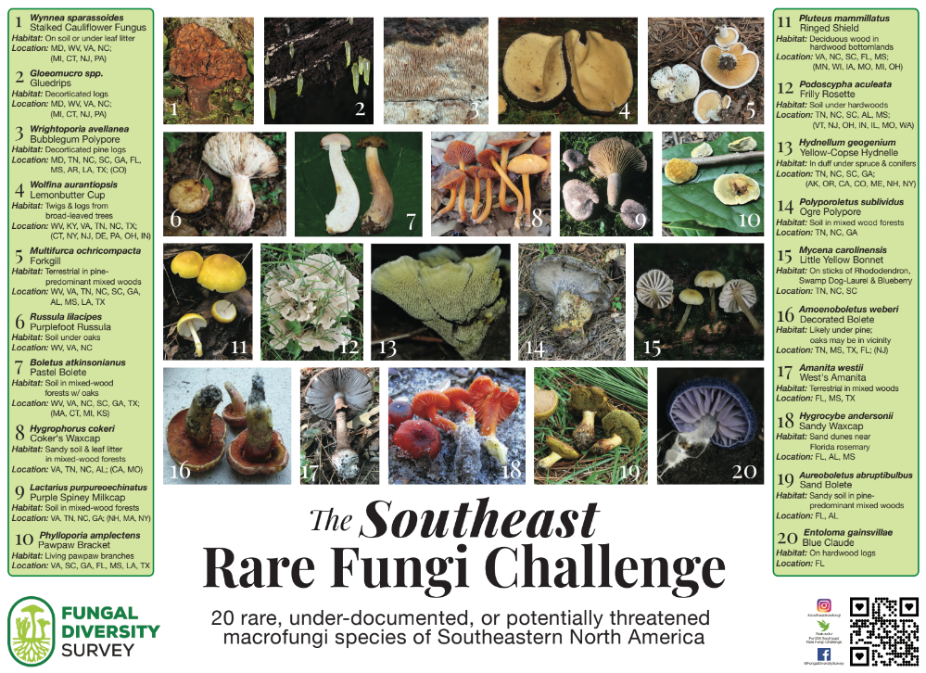

Meeting Information
AMS meetings place the first Tuesday of the month at 7pm CST via Zoom and are open to the public.
Join us Sept 5th and delve into the mysterious world of fungi as Sidnee Obersingleton presents 'Mushroom Sex.' Discover the intricate reproductive processes of mushrooms, from spore dispersal to hyphal knot formation. Sidnee demystifies the complex life cycles of these fascinating organisms, shedding light on their vital role in our ecosystem. Don't miss this captivating talk that's sure to leave you with a deeper appreciation of the fungal kingdom! As always, the recording will be available to paid AMS members via the Members Lounge on the website.

Link to the zoom meeting: Join Meeting
Meeting ID: 879 9643 3771
Passcode: 439211

2023 Scavenger Hunt
Have you heard about our scavenger hunt yet?! Find and properly identify as many mushrooms in Alabama as you can and win prizes at the end of the year! You get credit for finding the mushrooms when you add them to our project on iNaturalist. Read the full rules on our website here. Any observations you upload to iNaturalist will be automatically submitted to the project after joining. Joining the project is easy!
1. Download the iNaturalist app on your smartphone or access it via the website www.inaturalist.org.
2. Sign up for free to make your account.
3. Join the iNaturalist project titled “AMS 2022 Scavenger Hunt”
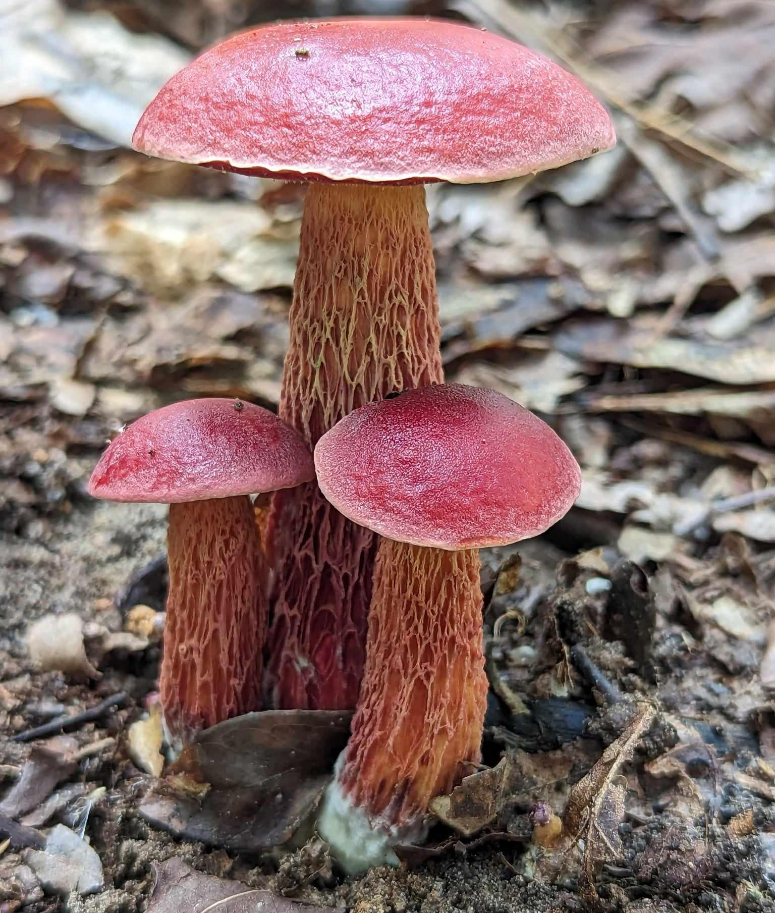
↠Must be a paid AMS member to win↞

Exeudoporus frostii
by Alisha Millican
Is there something you would like to see included each month? Do you have foray photos, a recipe or something else you would like to contribute? Reach out to us at www.almushroomsoc@gmail.com

